EXTENDED DATA
Genome-wide association studies of impulsive personality traits (BIS-11 and UPPS-P) and drug Experimentation in up to 22,861 adult research participants identify loci in the CACNA1I and CADM2 genes
Sandra Sanchez-Roige¹, Pierre Fontanillas², Sarah L. Elson², Joshua C. Gray³, Harriet de Wit⁴, James MacKillop⁵, Abraham A. Palmer^{1,6*}

Extended data - figures (25)

Table 1-1 Distribution of UPPSP scores (prior to quantile normalization).
Table 1-2 Distribution of BIS scores (prior to quantile normalization).
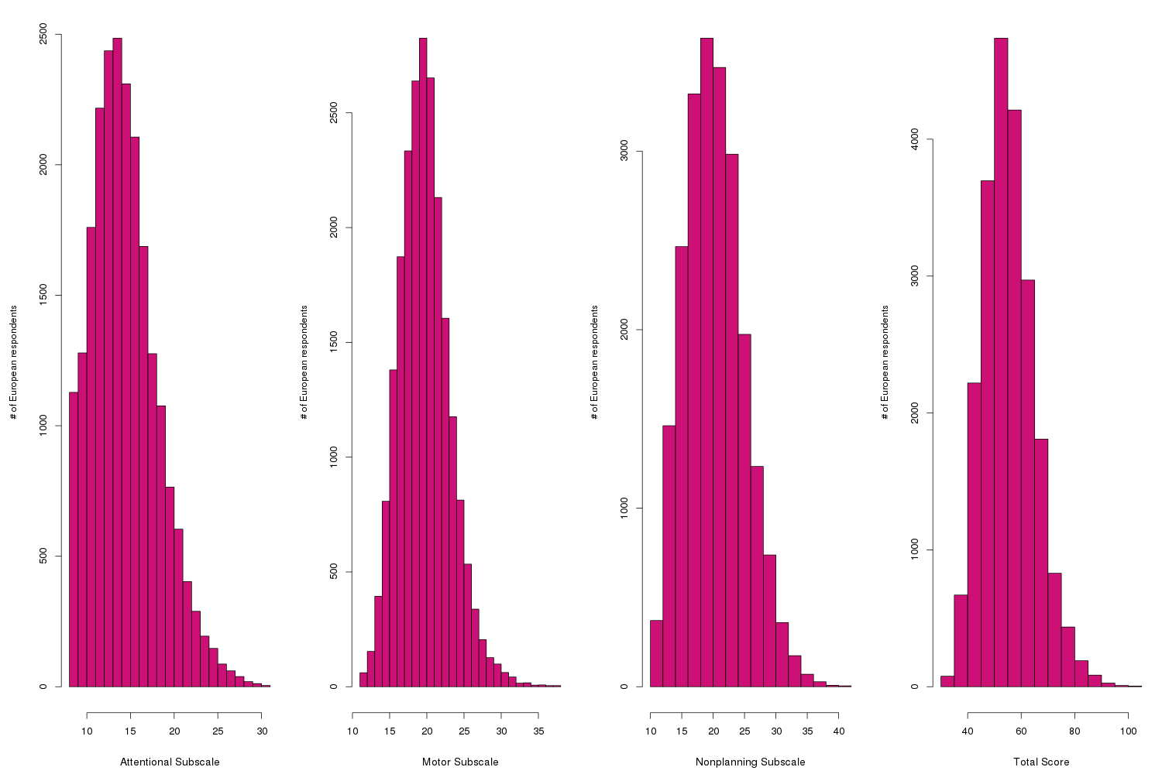

Table 1-3 Distribution of drug experimentation scores (prior to quantile normalization).

Figure 1-1 Quantile-quantile plot of GWAS for UPPSP sensation seeking.

Figure 1-2 Manhattan and QQ plots of GWAS results indicating the strongest associations between the 22 autosomes, X chromosome, and UPPSP premeditation. The results have been adjusted for a genomic control inflation factor λ=1.020 (sample size = 22,774).

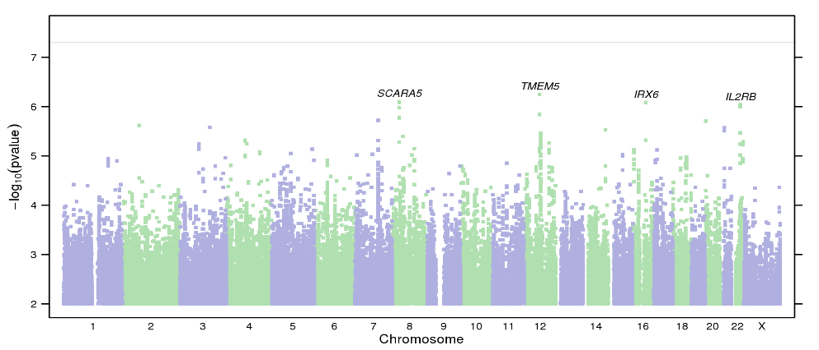
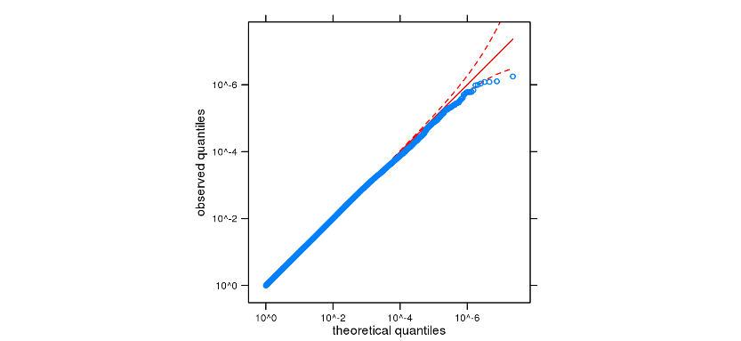

Figure 1-3 Manhattan and QQ plots of GWAS results indicating the strongest associations between the 22 autosomes, X chromosome, and UPPSP positive urgency. The results have been adjusted for a genomic control inflation factor λ=1.024 (sample size = 22,738).

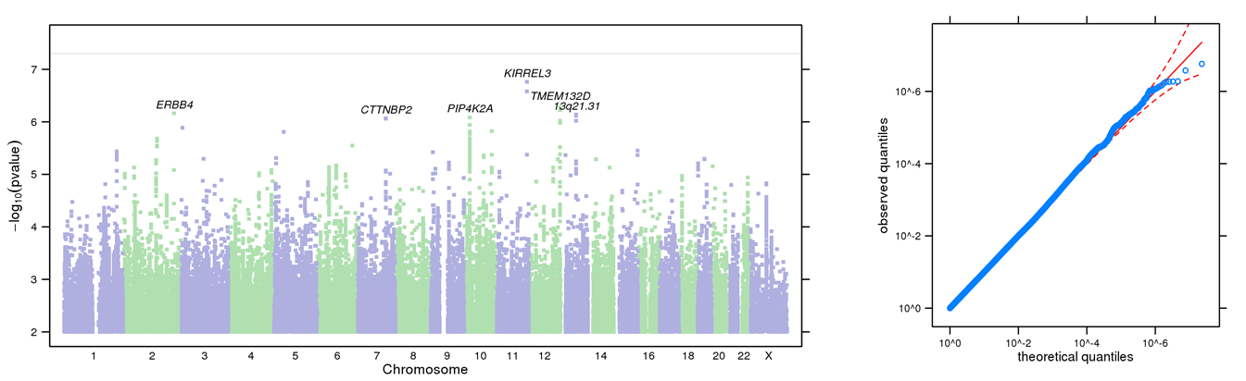

Figure 1-4 Manhattan and QQ plots of GWAS results indicating the strongest associations between the 22 autosomes, X chromosome, and UPPSP perseverance. The results have been adjusted for a genomic control inflation factor λ=1.023 (sample size = 22,861).

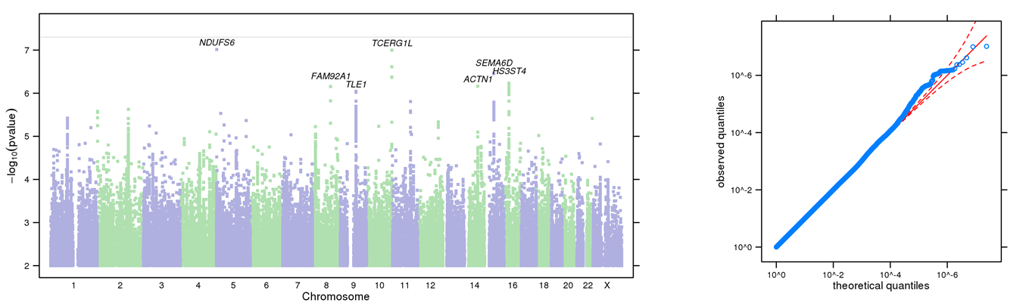

Figure 1-5 Manhattan and QQ plots of GWAS results indicating the strongest associations between the 22 autosomes, X chromosome, and BIS total score. The results have been adjusted for a genomic control inflation factor λ=1.027 (sample size = 21,495).

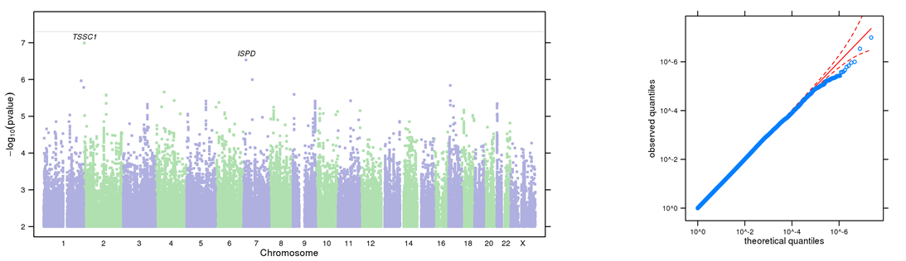

Figure 1-6 Manhattan and QQ plots of GWAS results indicating the strongest associations between the 22 autosomes, X chromosome, and BIS attentional subscale. The results have been adjusted for a genomic control inflation factor λ=1.023 (sample size = 21,876).

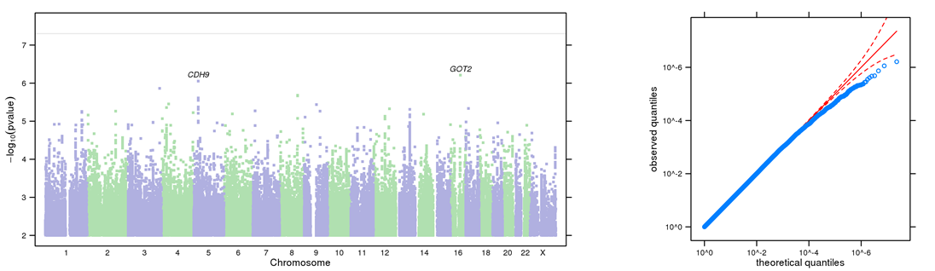

Figure 1-7 Manhattan and QQ plots of GWAS results indicating the strongest associations between the 22 autosomes, X chromosome, and BIS motor subscale. The results have been adjusted for a genomic control inflation factor λ=1.016 (sample size = 21,806).

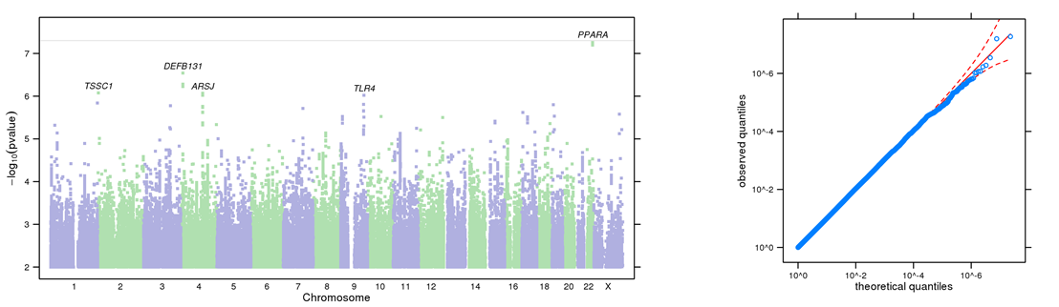

Figure 1-8 Manhattan and QQ plots of GWAS results indicating the strongest associations between the 22 autosomes, X chromosome, and BIS nonplanning subscale. The results have been adjusted for a genomic control inflation factor λ=1.019 (sample size = 21,786).

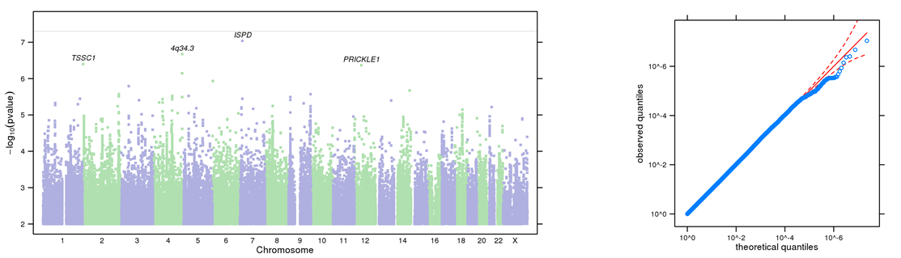

Figure 1-9 QQ plot of GWAS results indicating the strongest associations between the 22 autosomes, X chromosome, and drug experimentation. The results have been adjusted for a genomic control inflation factor factor λ=1.031 (sample size = 22,572).

Figure 1-10 Regional association plots focusing on genetic variants associated with UPPSP sensation seeking. This plot was generated using LocusZoom (1). The -log₁₀(P value) is shown on the left y-axis; position in Mb is on the x-axis. Recombination rates (expressed in centiMorgans cM per Mb; NCBI Build GRCh37; highlighted in blue) are shown on the right y-axis. Pairwise linkage disequilibrium (r²) of each SNP with the top SNP in the region is indicated by its color. Crossed points represent imputed SNPs, circles represent directly genotyped SNPs.
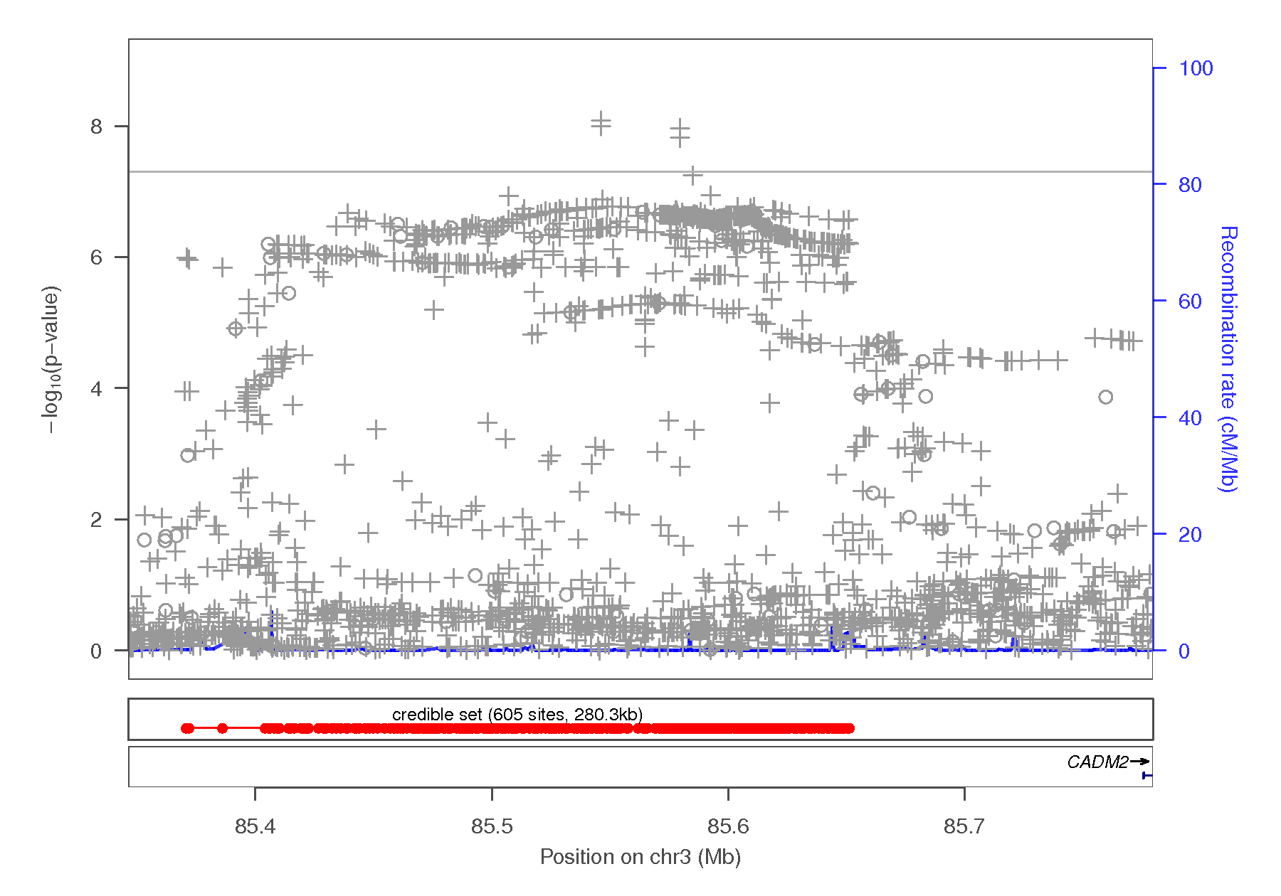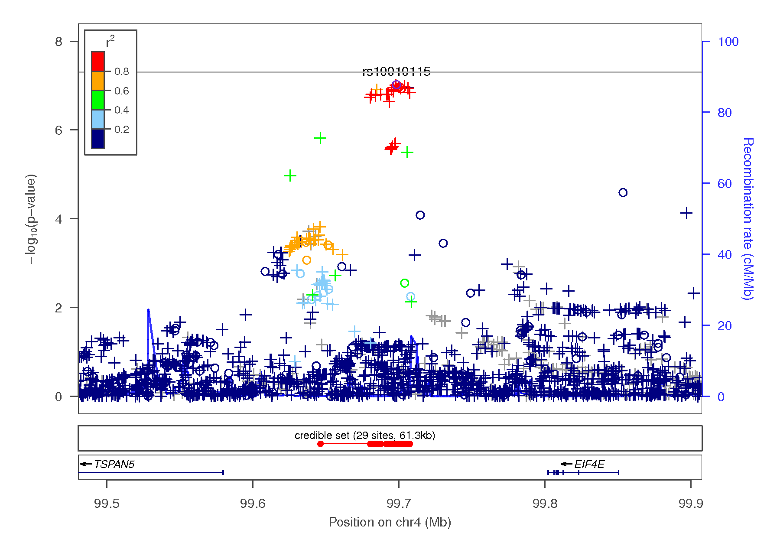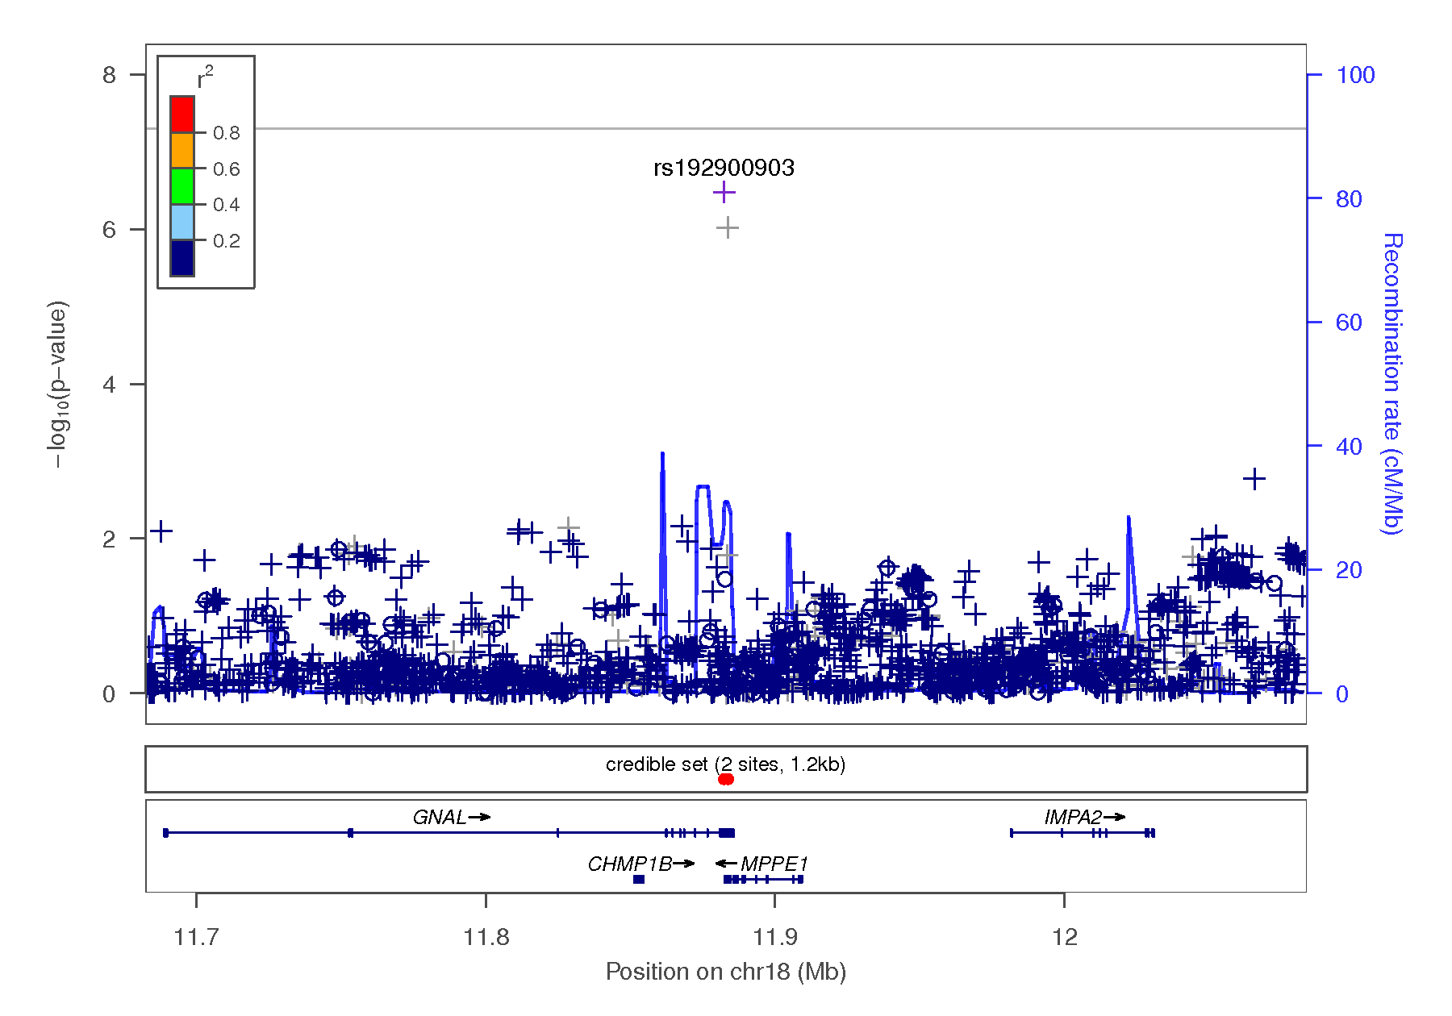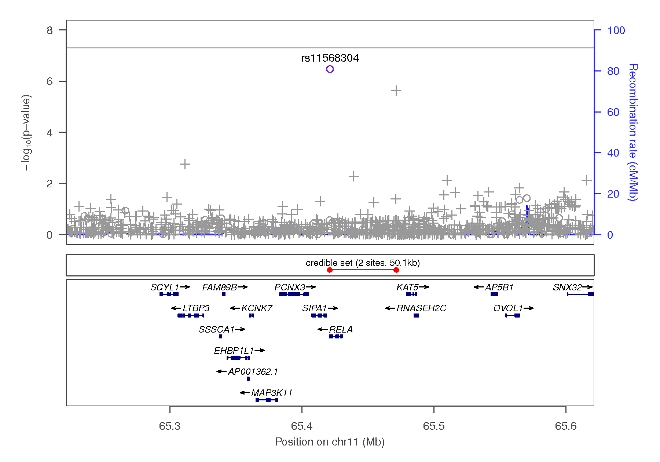
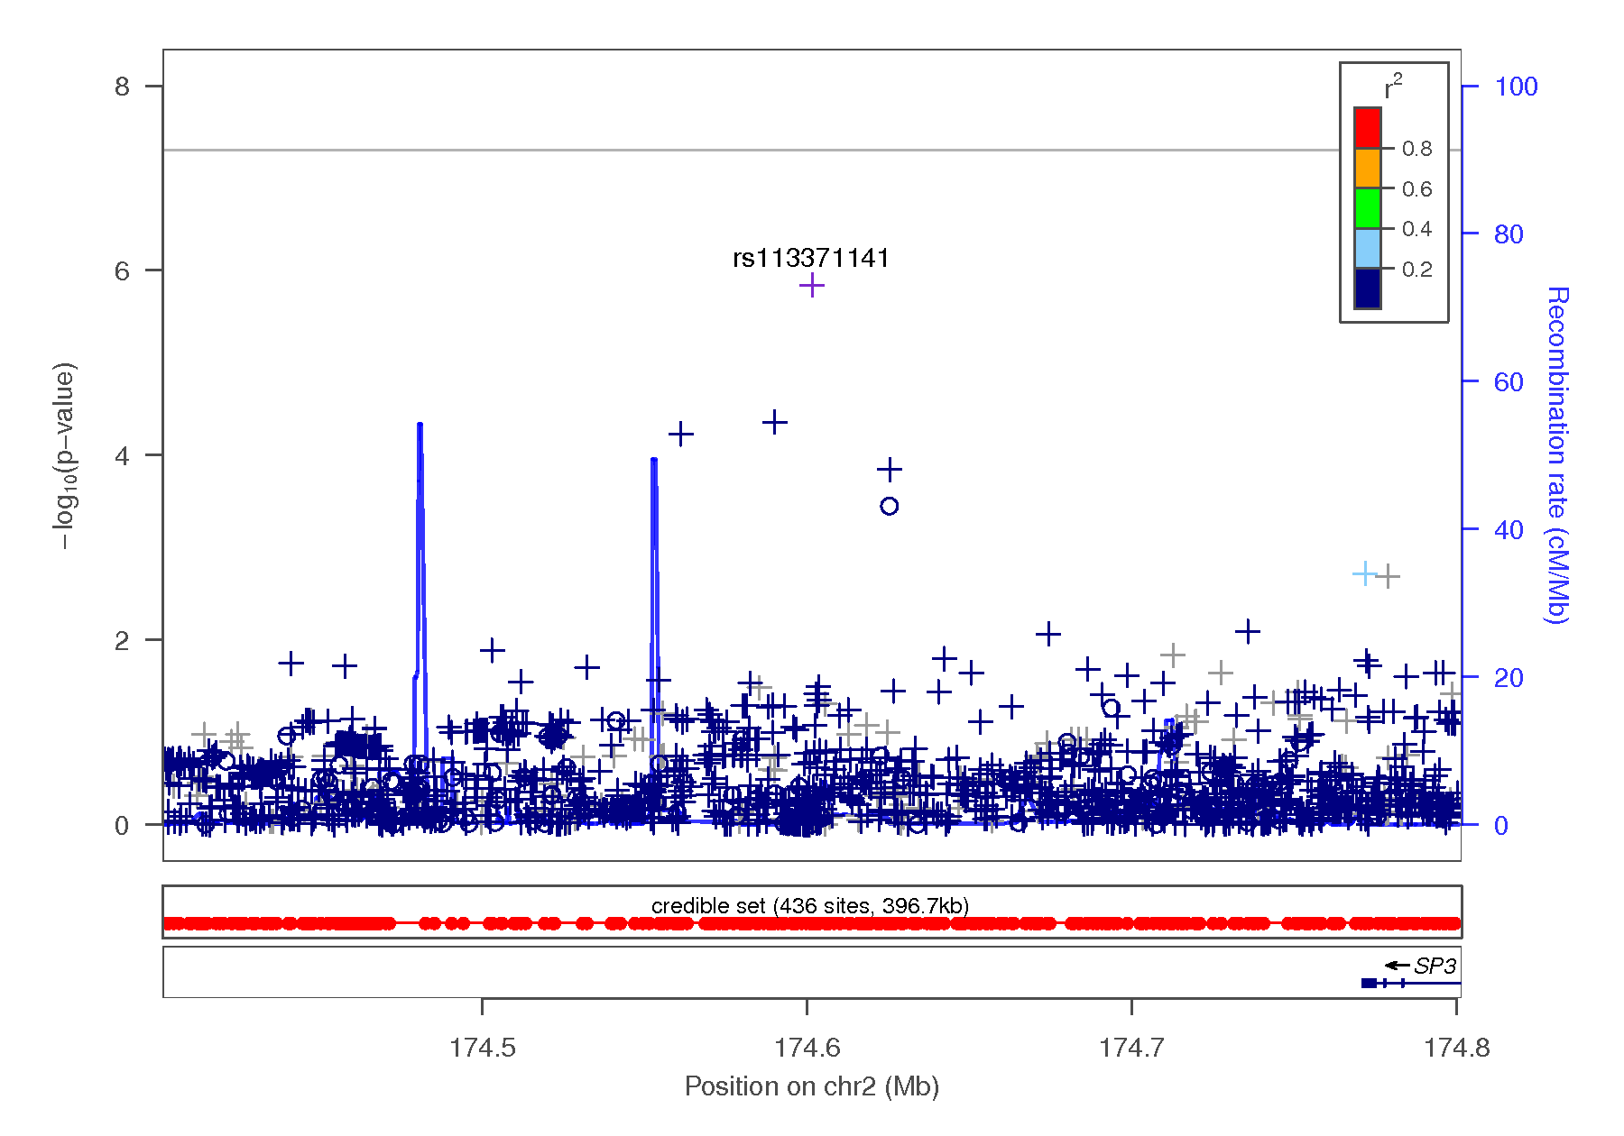

Figure 1-11 Regional association plots focusing on genetic variants associated with UPPSP premeditation. This plot was generated using LocusZoom (1). The -log₁₀(P value) is shown on the left y-axis; position in Mb is on the x-axis. Recombination rates (expressed in centiMorgans cM per Mb; NCBI Build GRCh37; highlighted in blue) are shown on the right y-axis. Pairwise linkage disequilibrium (r²) of each SNP with the top SNP in the region is indicated by its color. Crossed points represent imputed SNPs, circles represent directly genotyped SNPs.
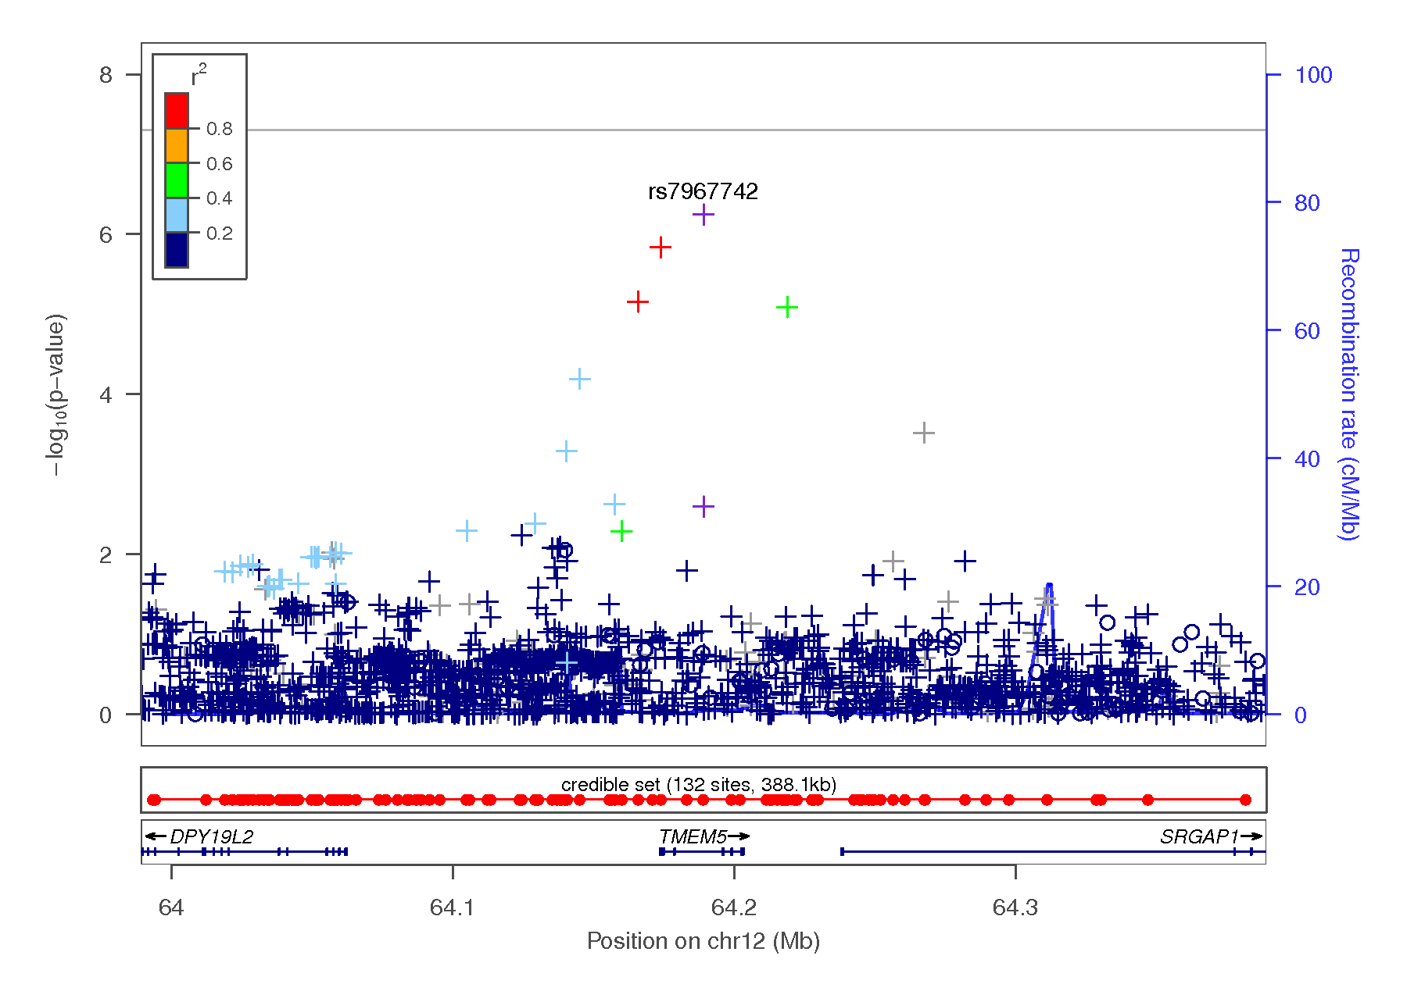
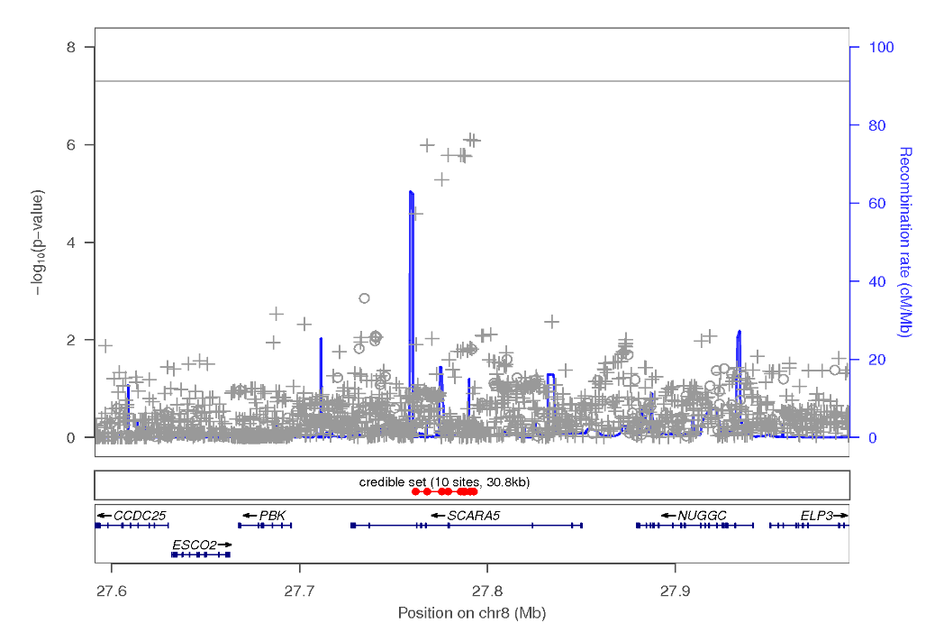
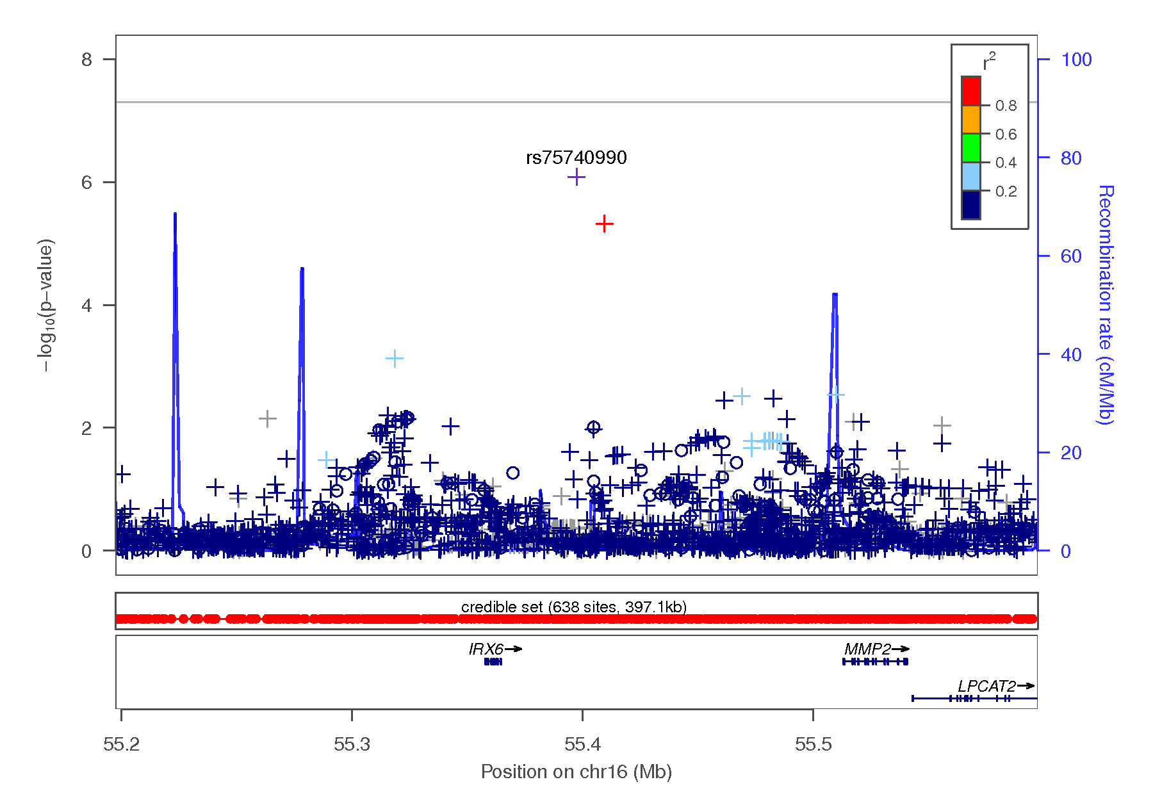
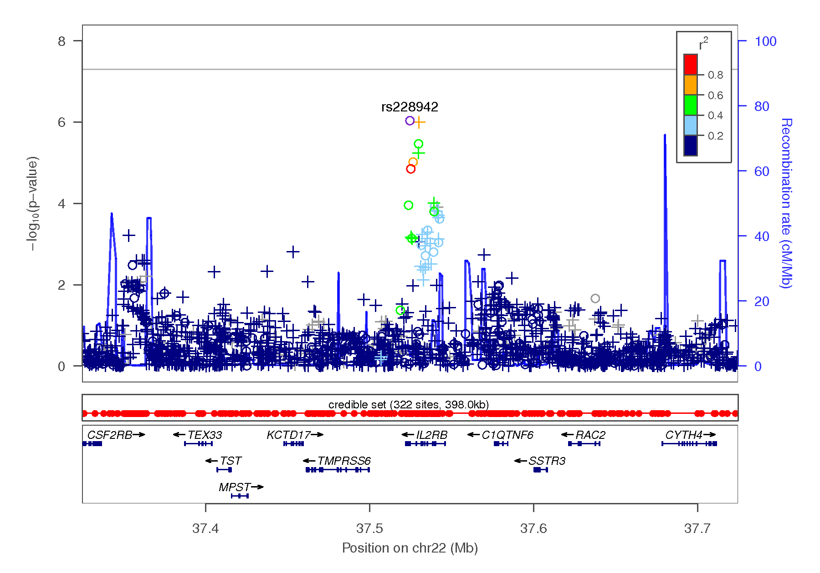
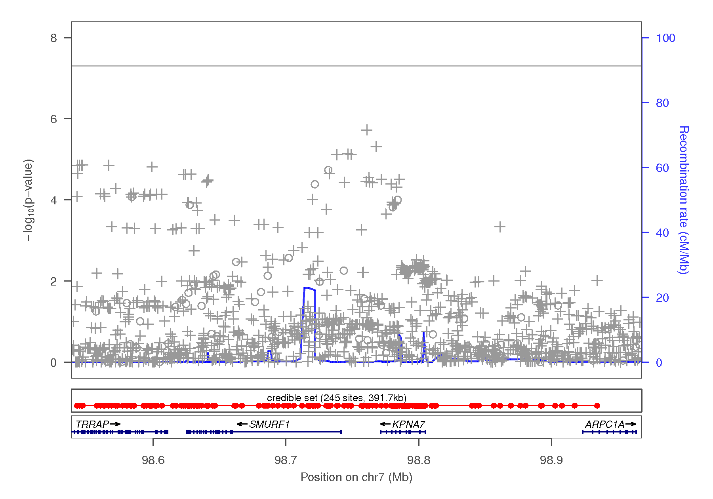

Figure 1-12 Regional association plots focusing on genetic variants associated with UPPSP positive urgency. This plot was generated using LocusZoom (1). The -log₁₀(P value) is shown on the left y-axis; position in Mb is on the x-axis. Recombination rates (expressed in centiMorgans cM per Mb; NCBI Build GRCh37; highlighted in blue) are shown on the right y-axis. Pairwise linkage disequilibrium (r²) of each SNP with the top SNP in the region is indicated by its color. Crossed points represent imputed SNPs, circles represent directly genotyped SNPs.
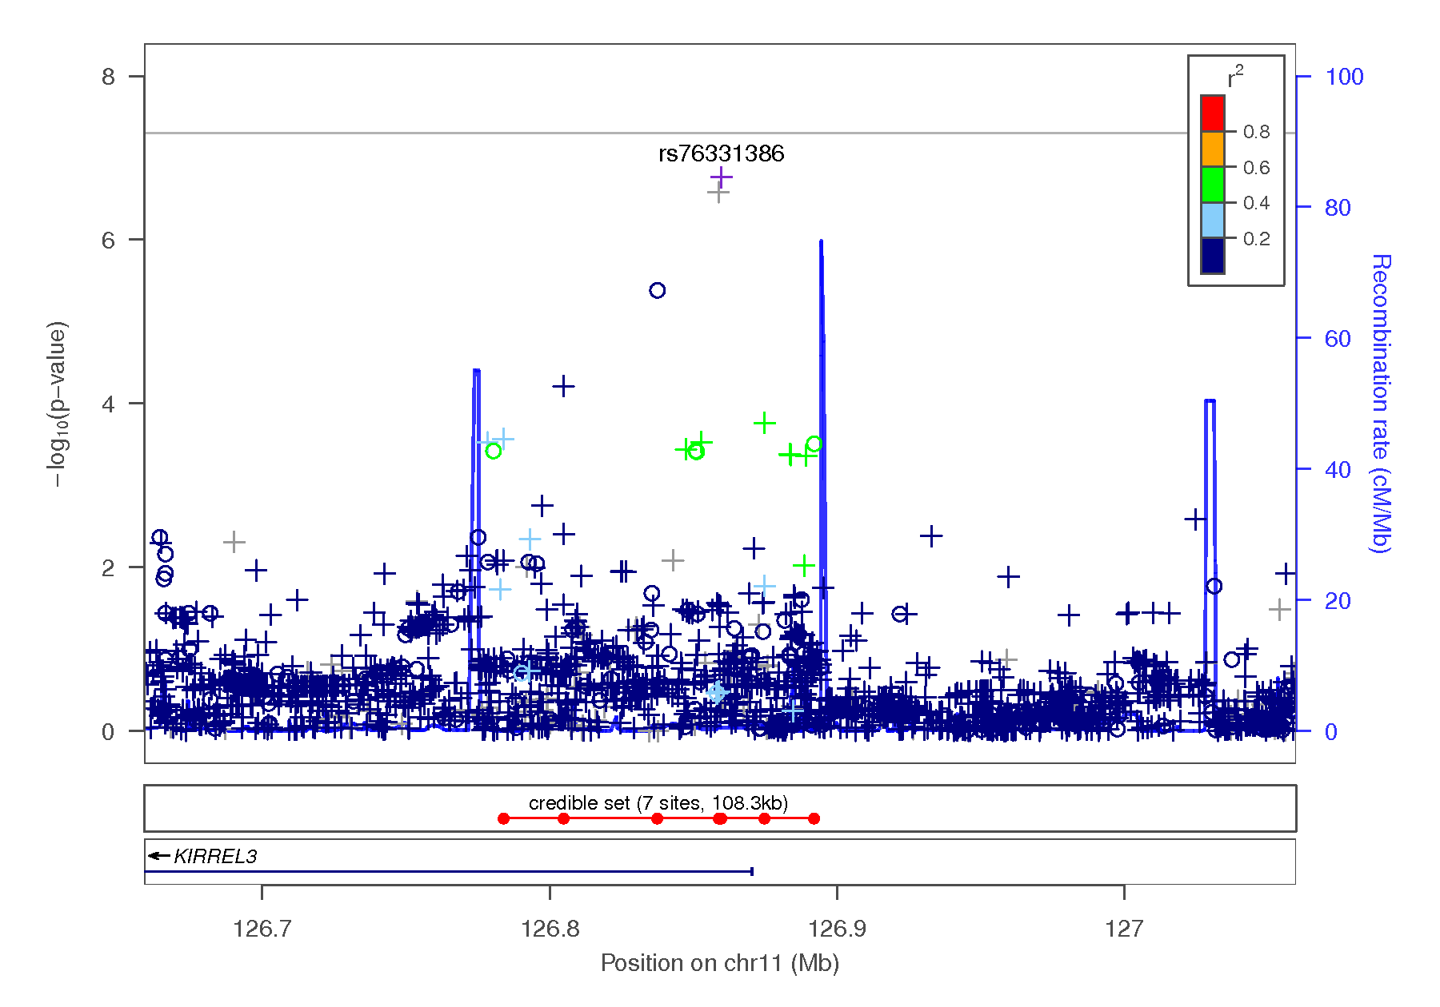
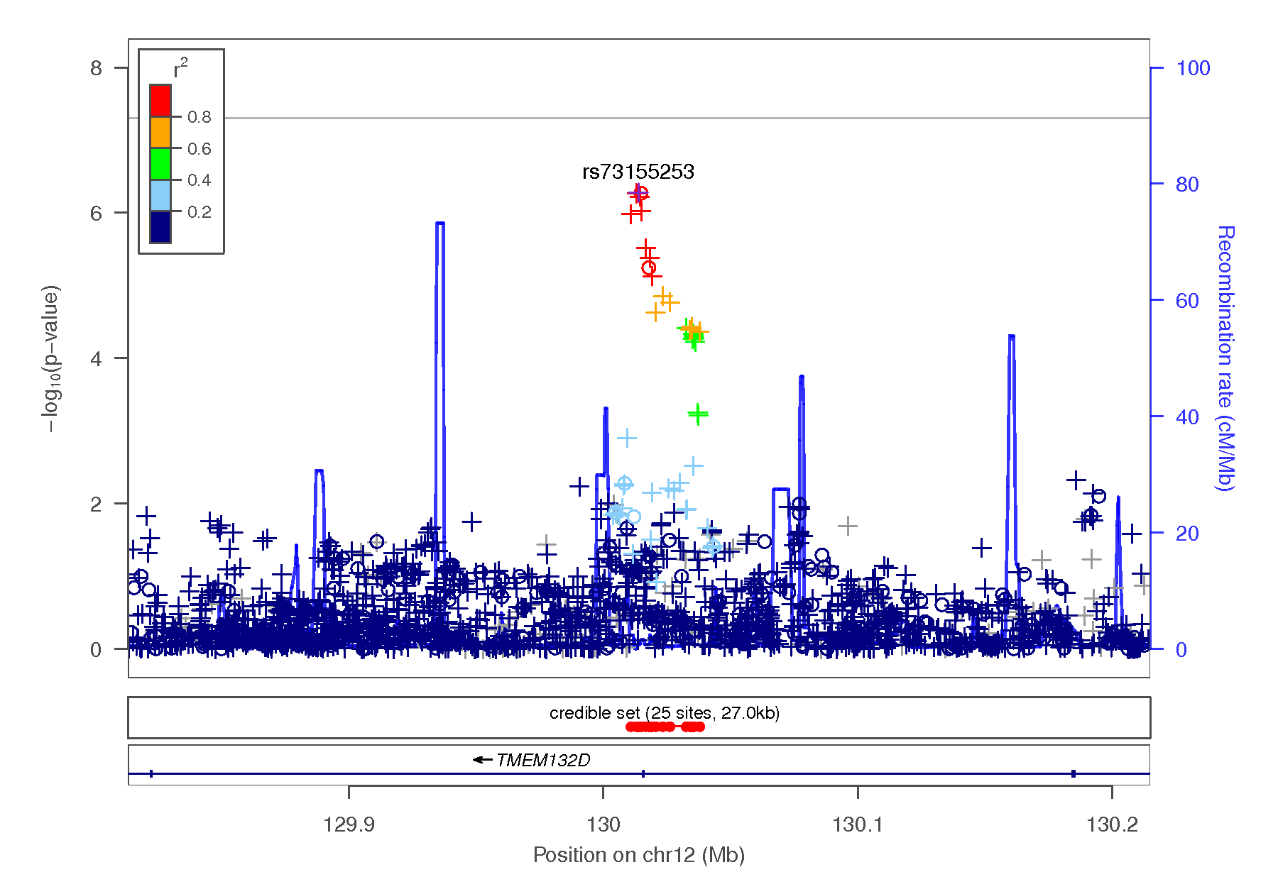
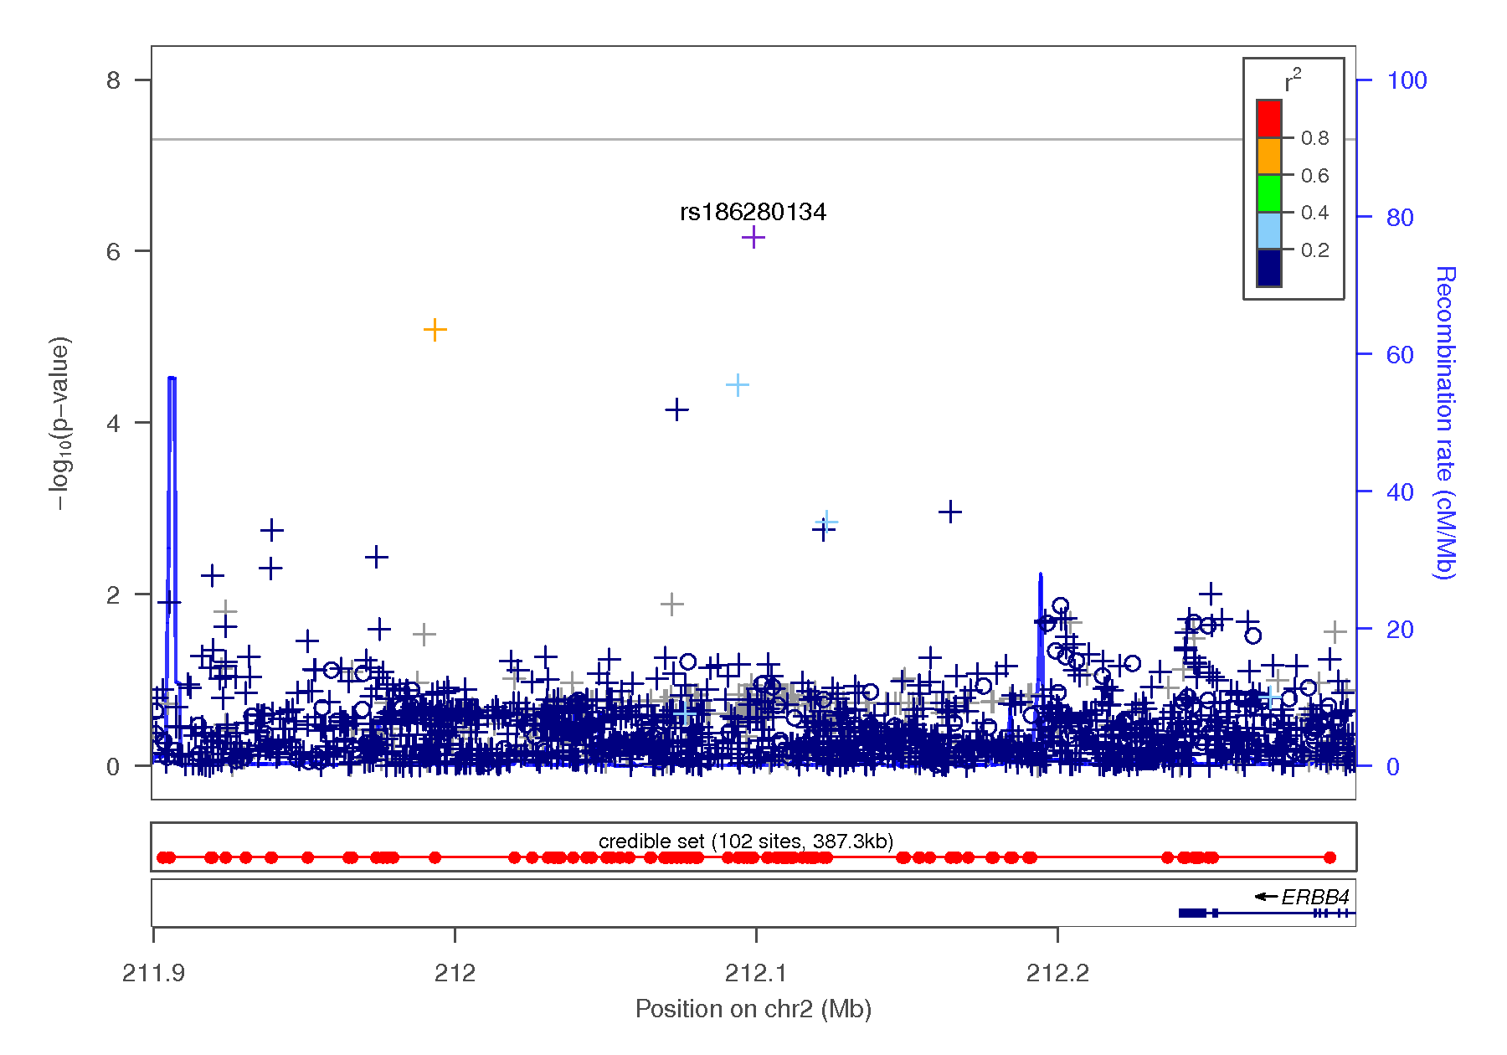
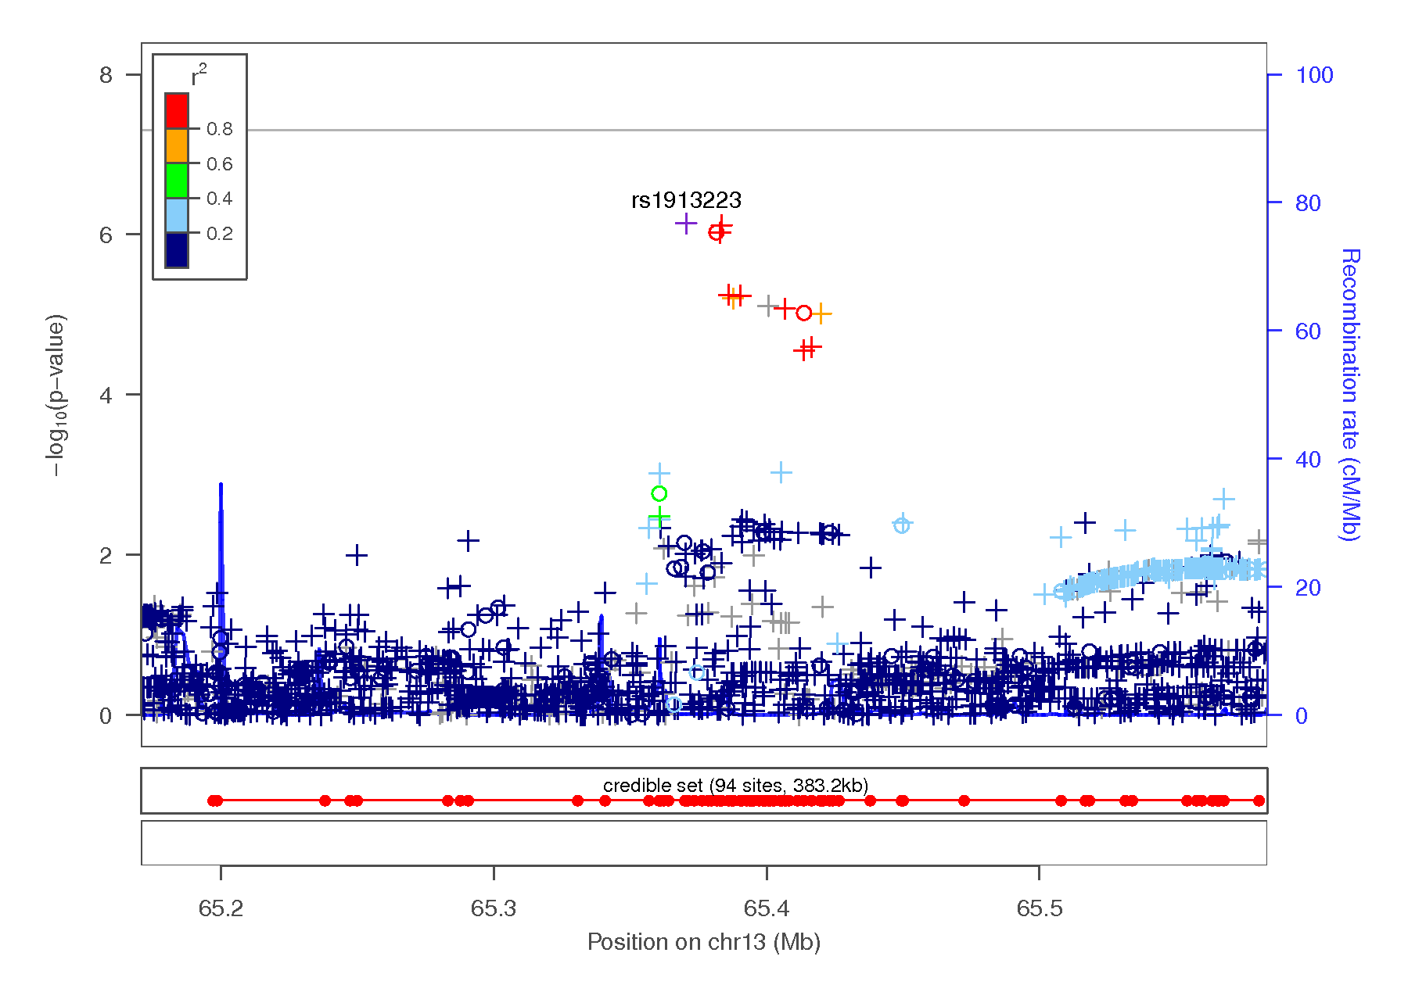
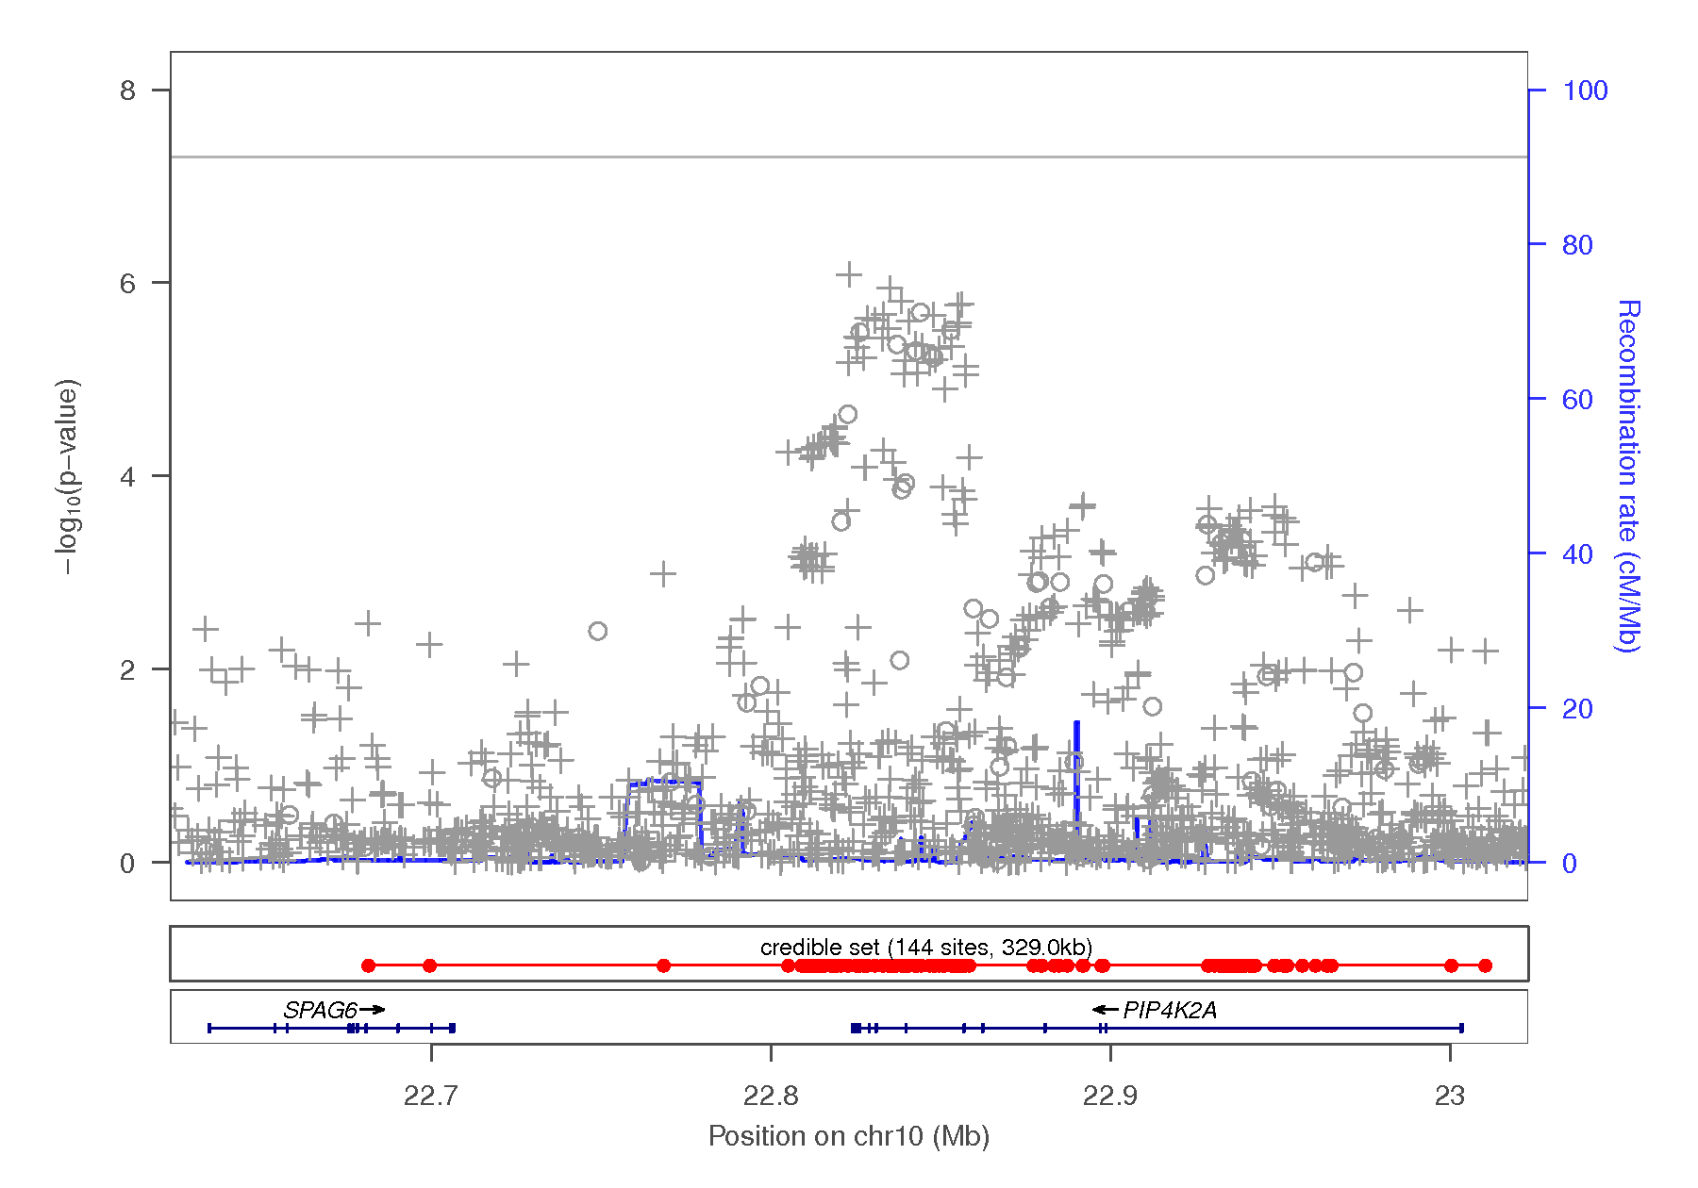

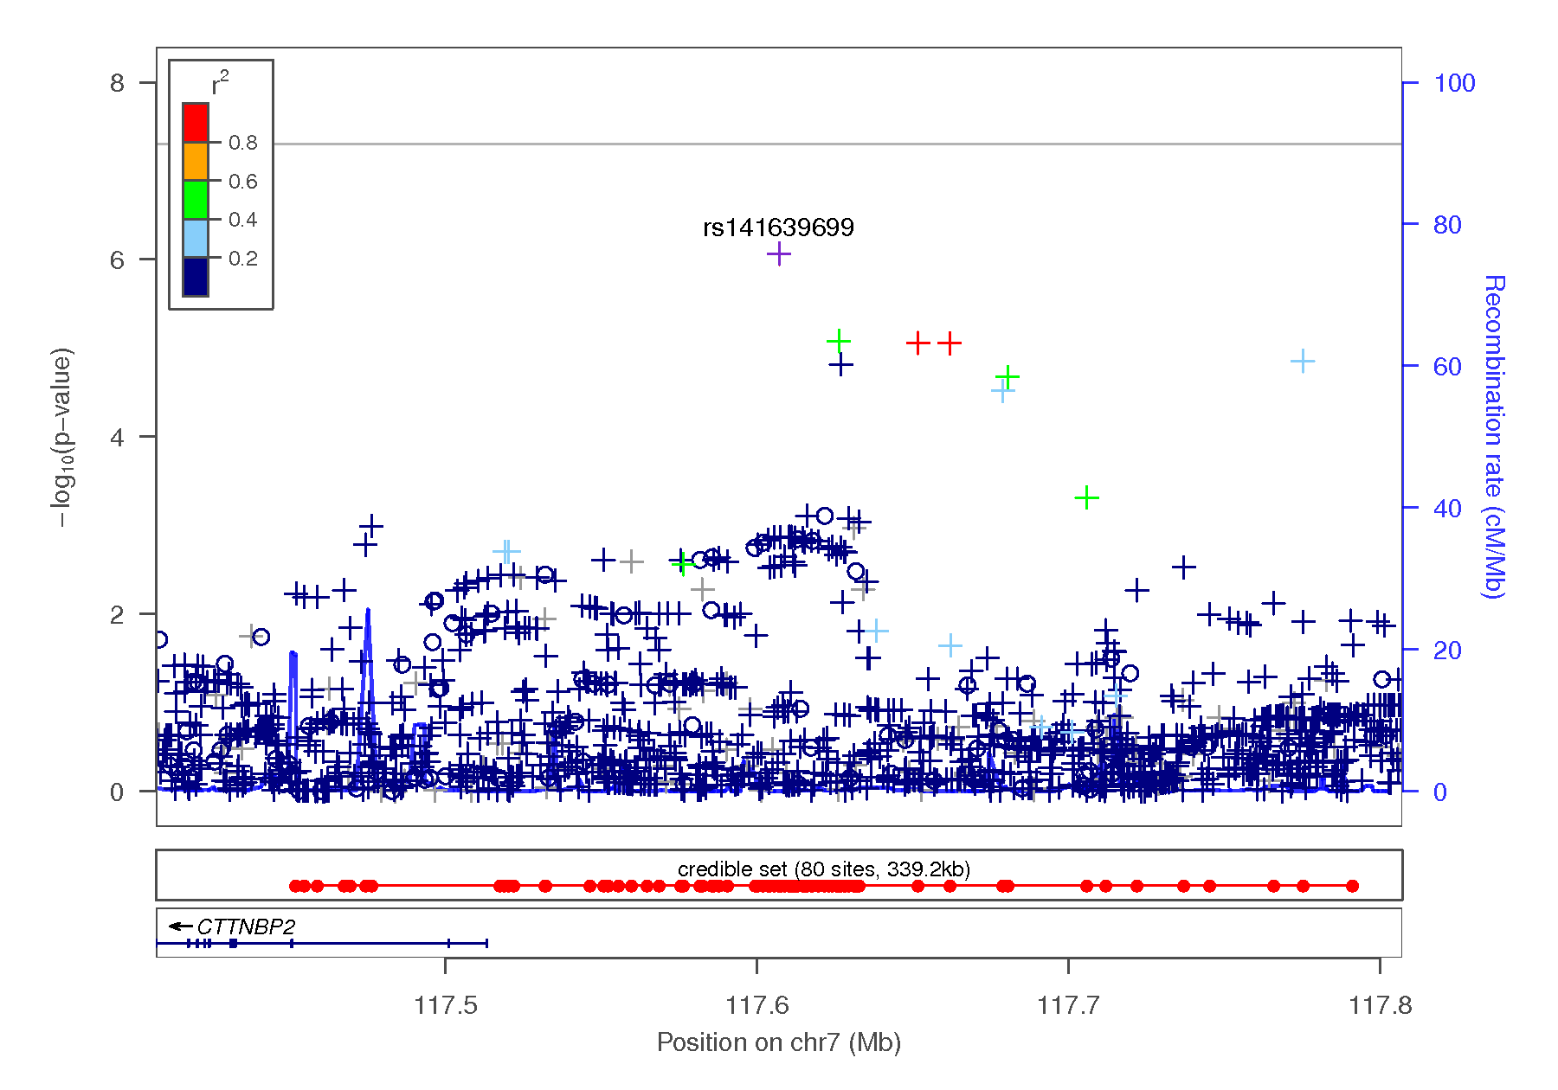
Figure 1-13 Regional association plots focusing on genetic variants associated with UPPSP perseverance. This plot was generated using LocusZoom (1). The -log₁₀(P value) is shown on the left y-axis; position in Mb is on the x-axis. Recombination rates (expressed in centiMorgans cM per Mb; NCBI Build GRCh37; highlighted in blue) are shown on the right y-axis. Pairwise linkage disequilibrium (r²) of each SNP with the top SNP in the region is indicated by its color. Crossed points represent imputed SNPs, circles represent directly genotyped SNPs.
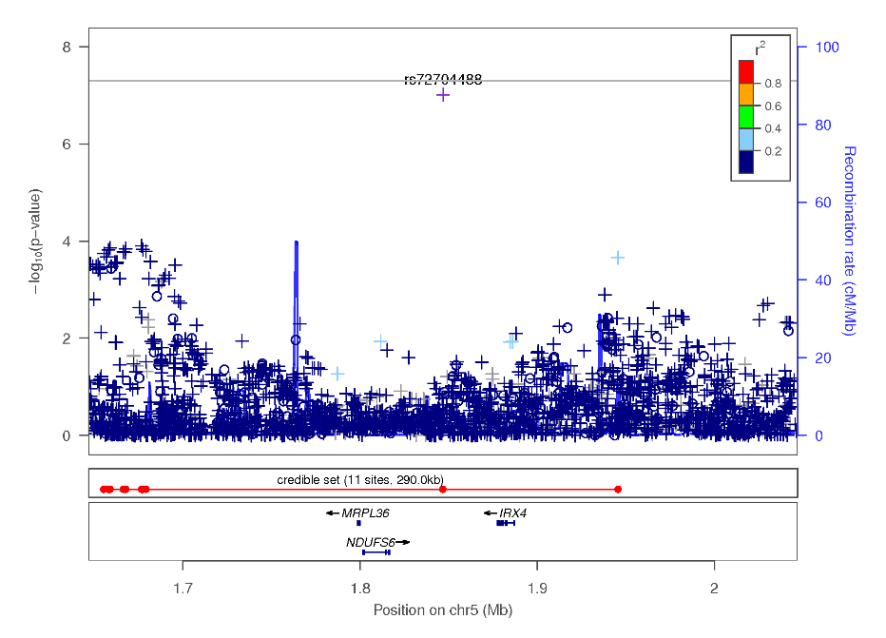
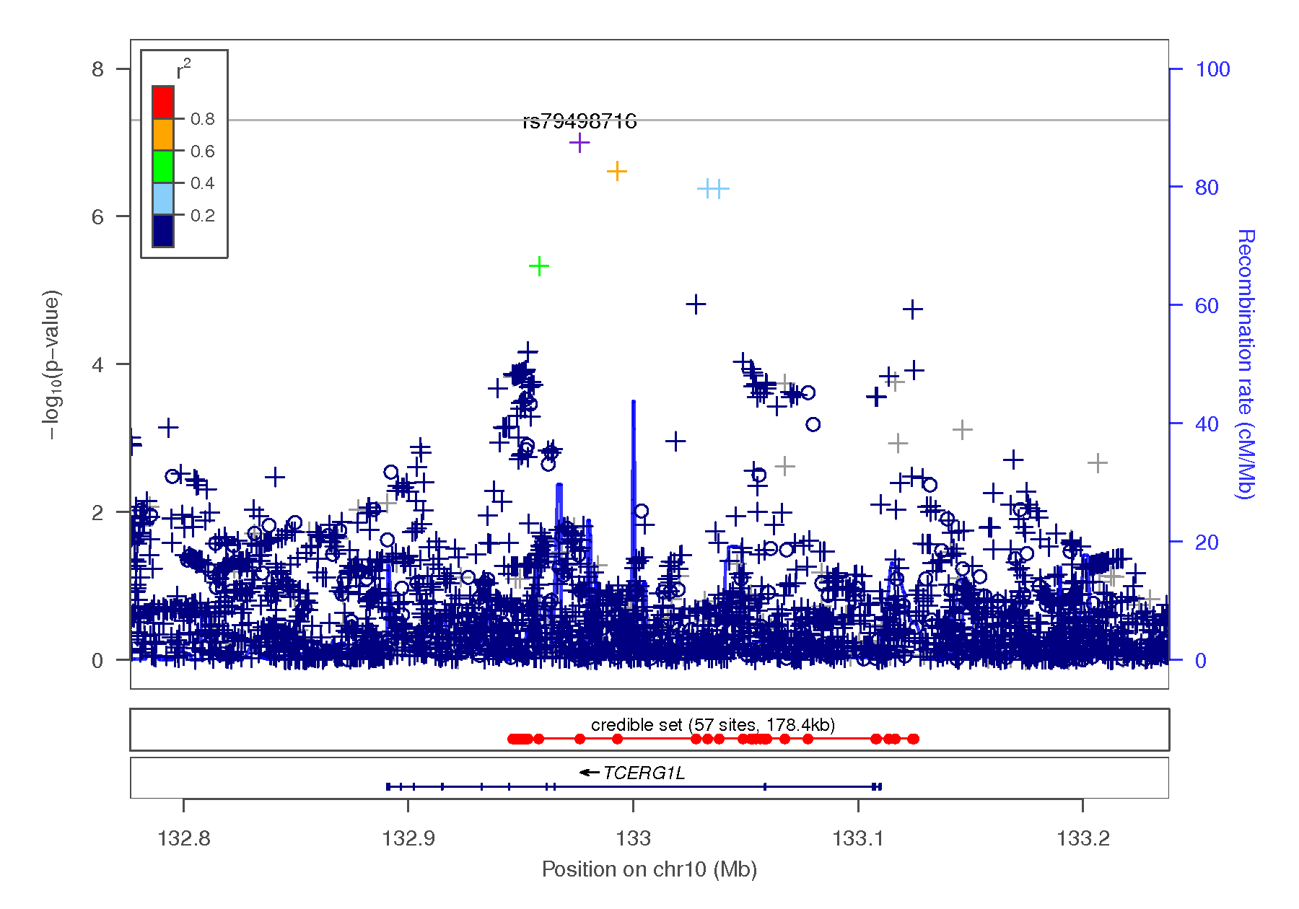
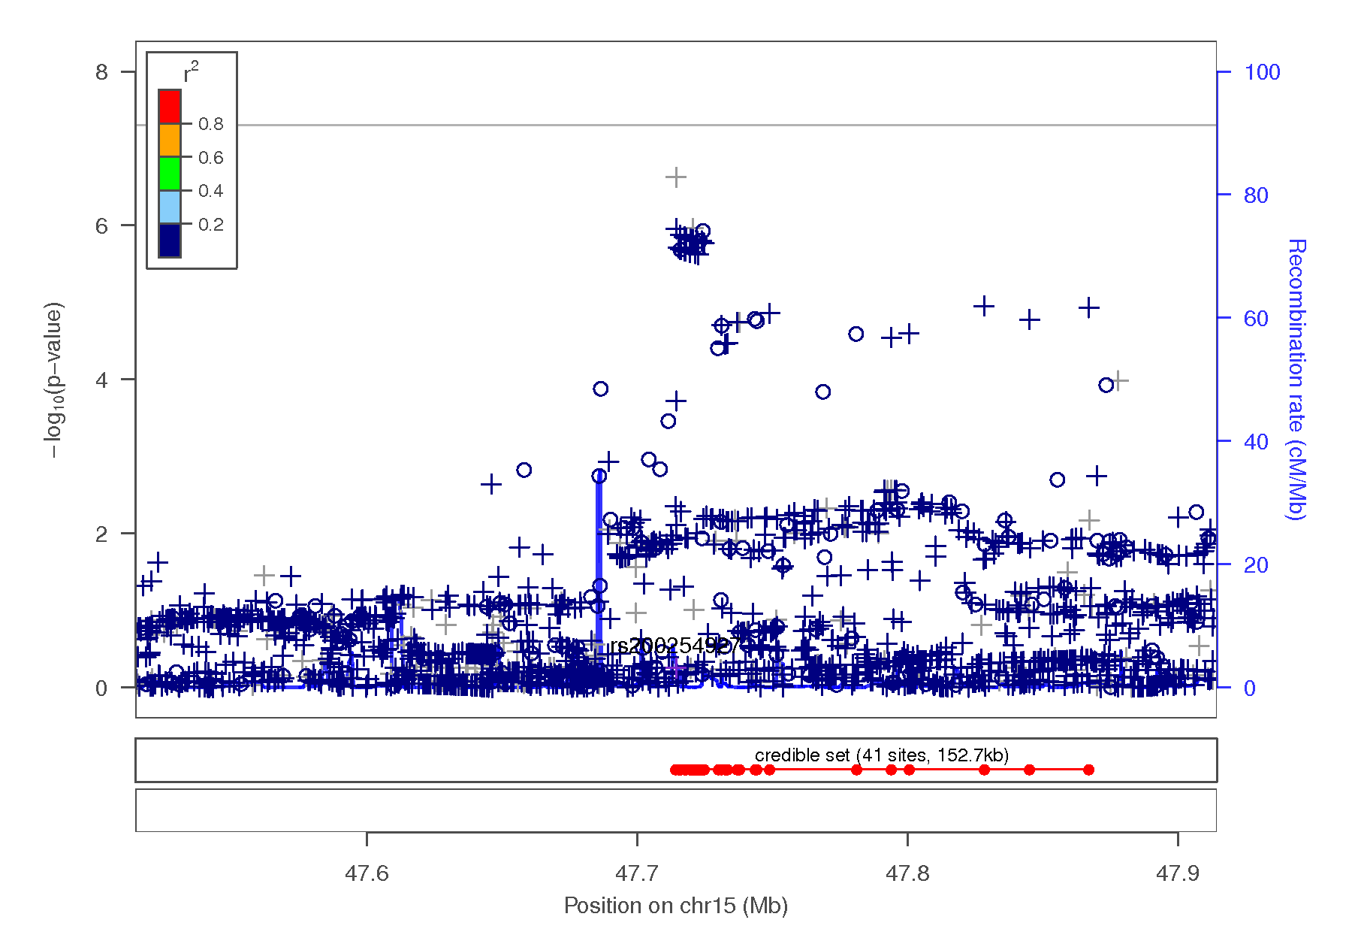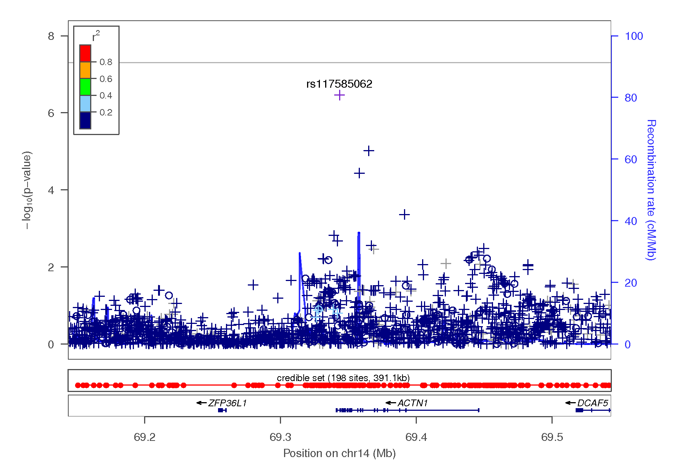
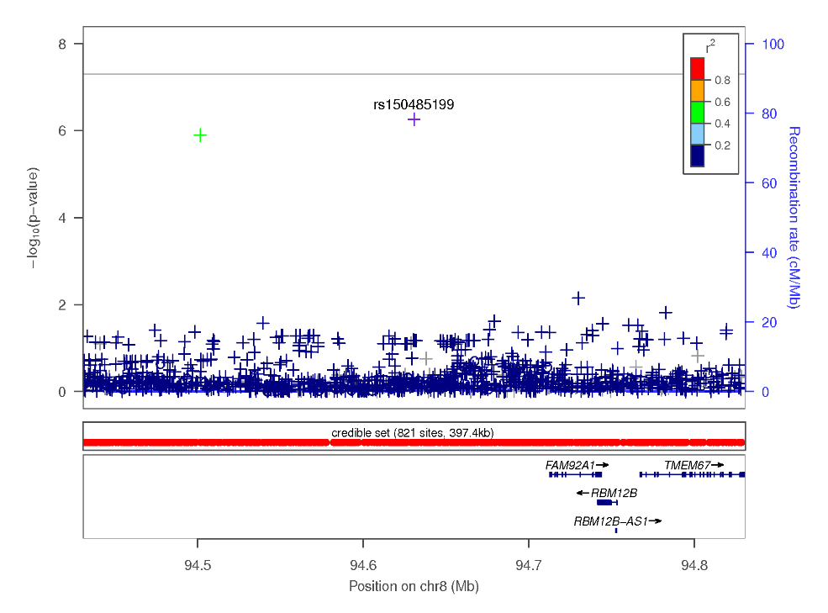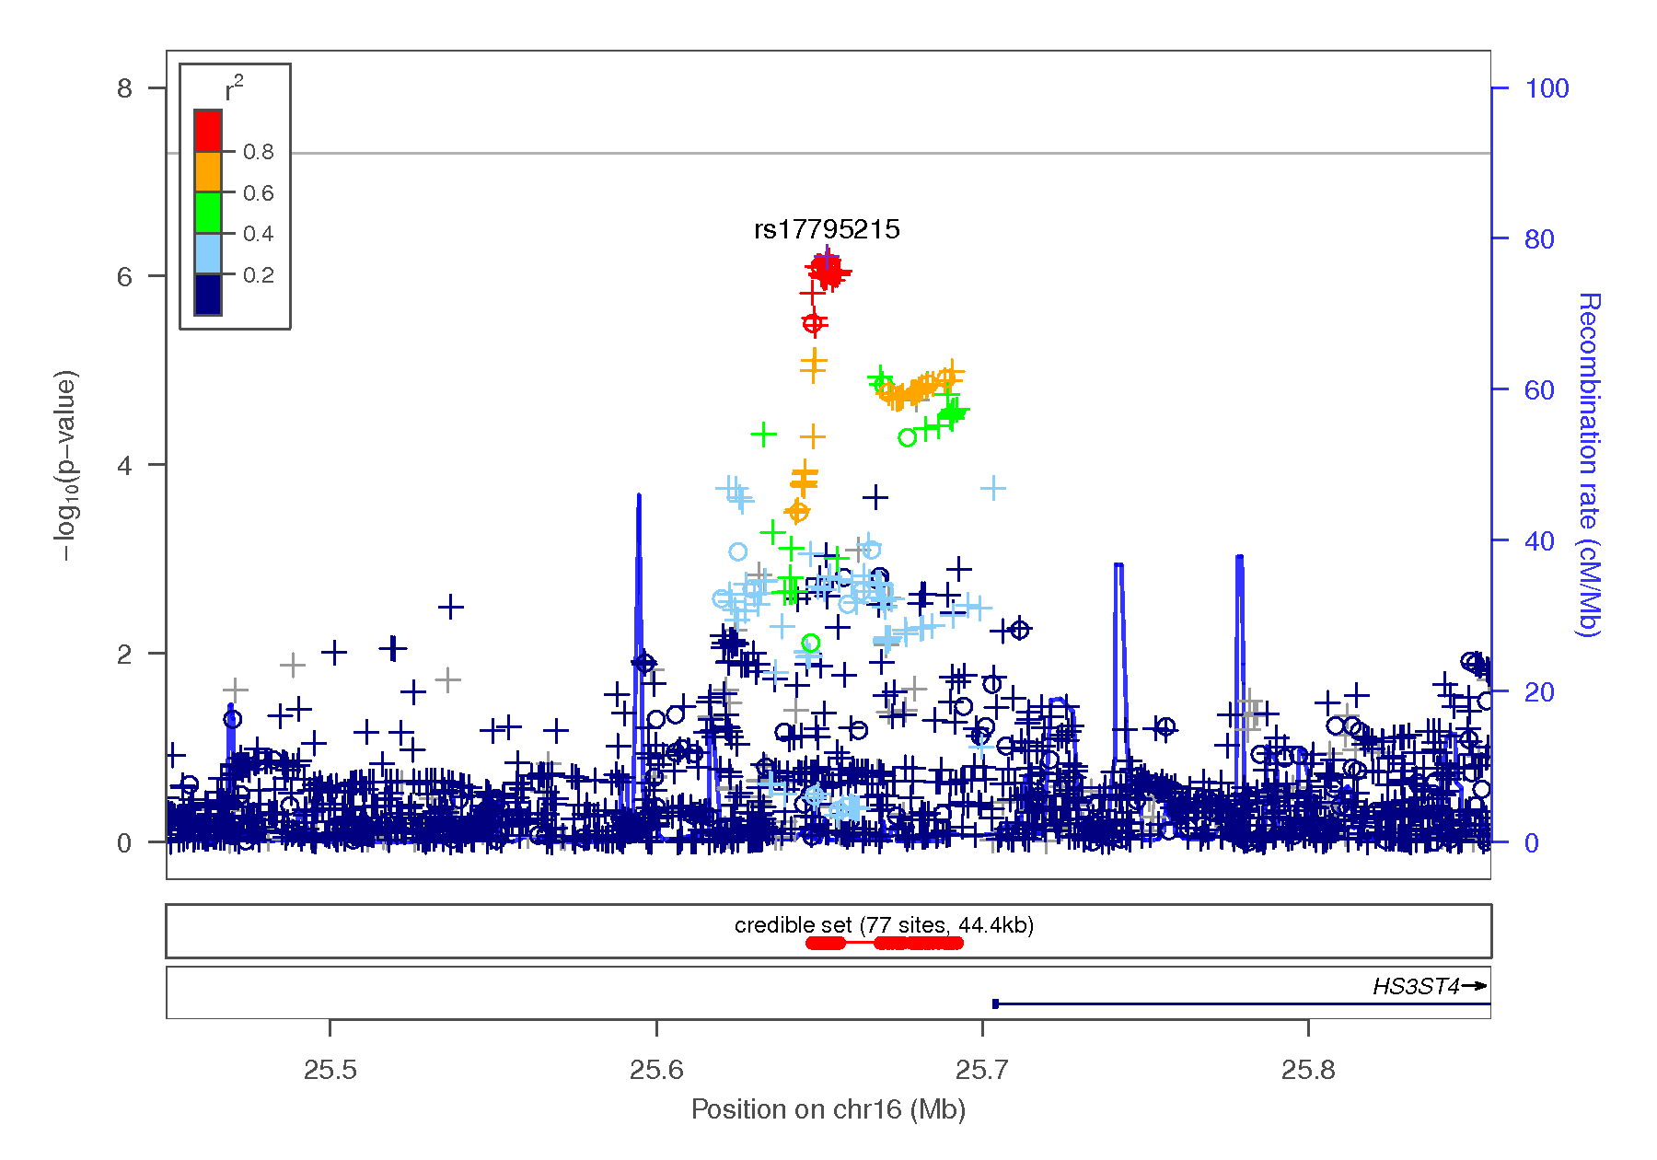

Figure 1-14 Regional association plots focusing on genetic variants associated with BIS total score. This plot was generated using LocusZoom (1). The -log₁₀(P value) is shown on the left y-axis; position in Mb is on the x-axis. Recombination rates (expressed in centiMorgans cM per Mb; NCBI Build GRCh37; highlighted in blue) are shown on the right y-axis. Pairwise linkage disequilibrium (r²) of each SNP with the top SNP in the region is indicated by its color. Crossed points represent imputed SNPs, circles represent directly genotyped SNPs.
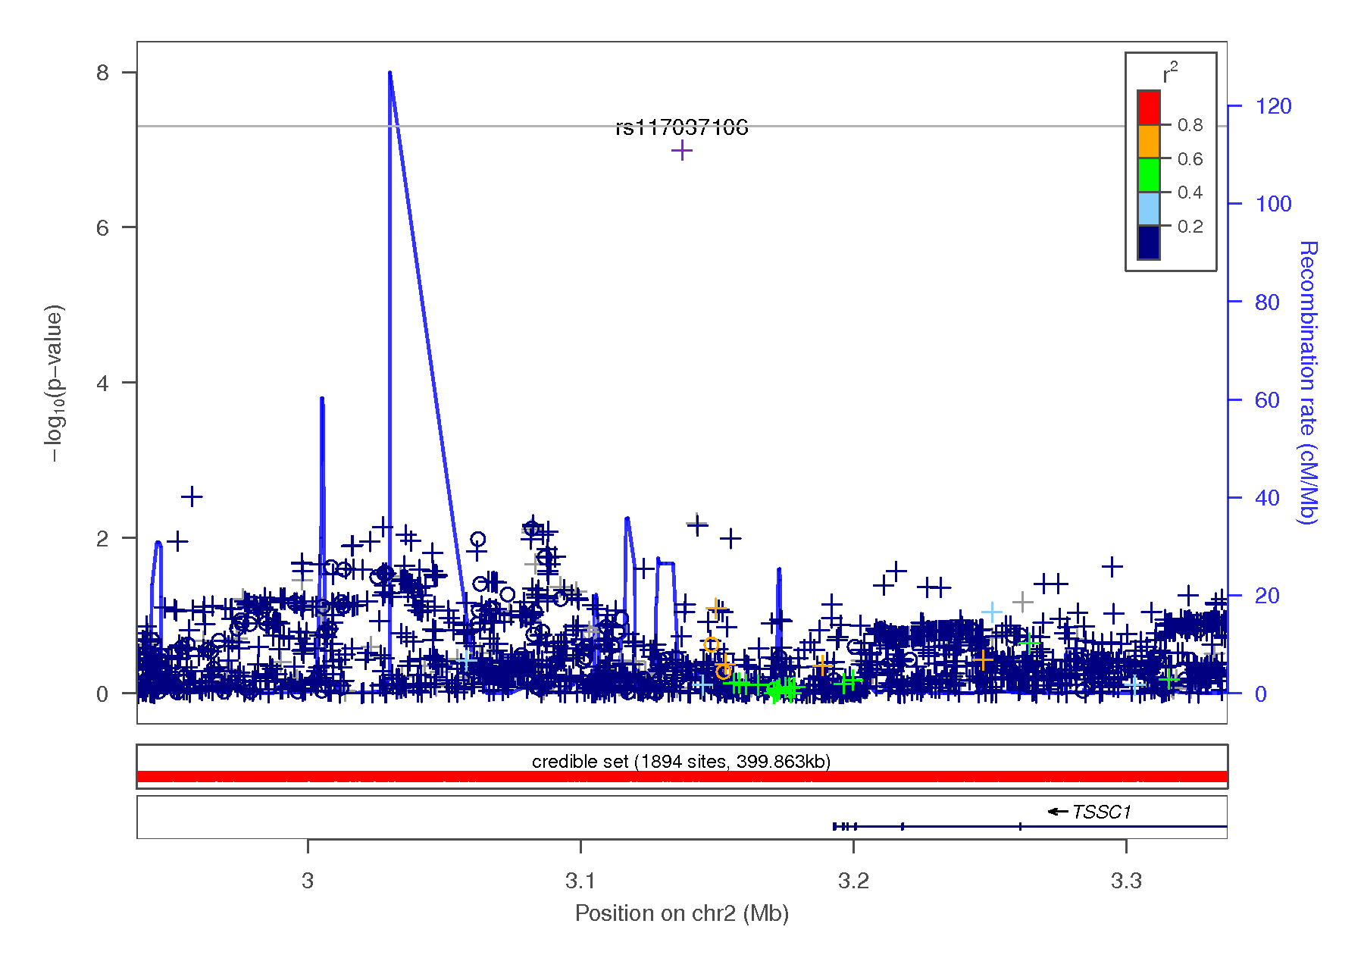
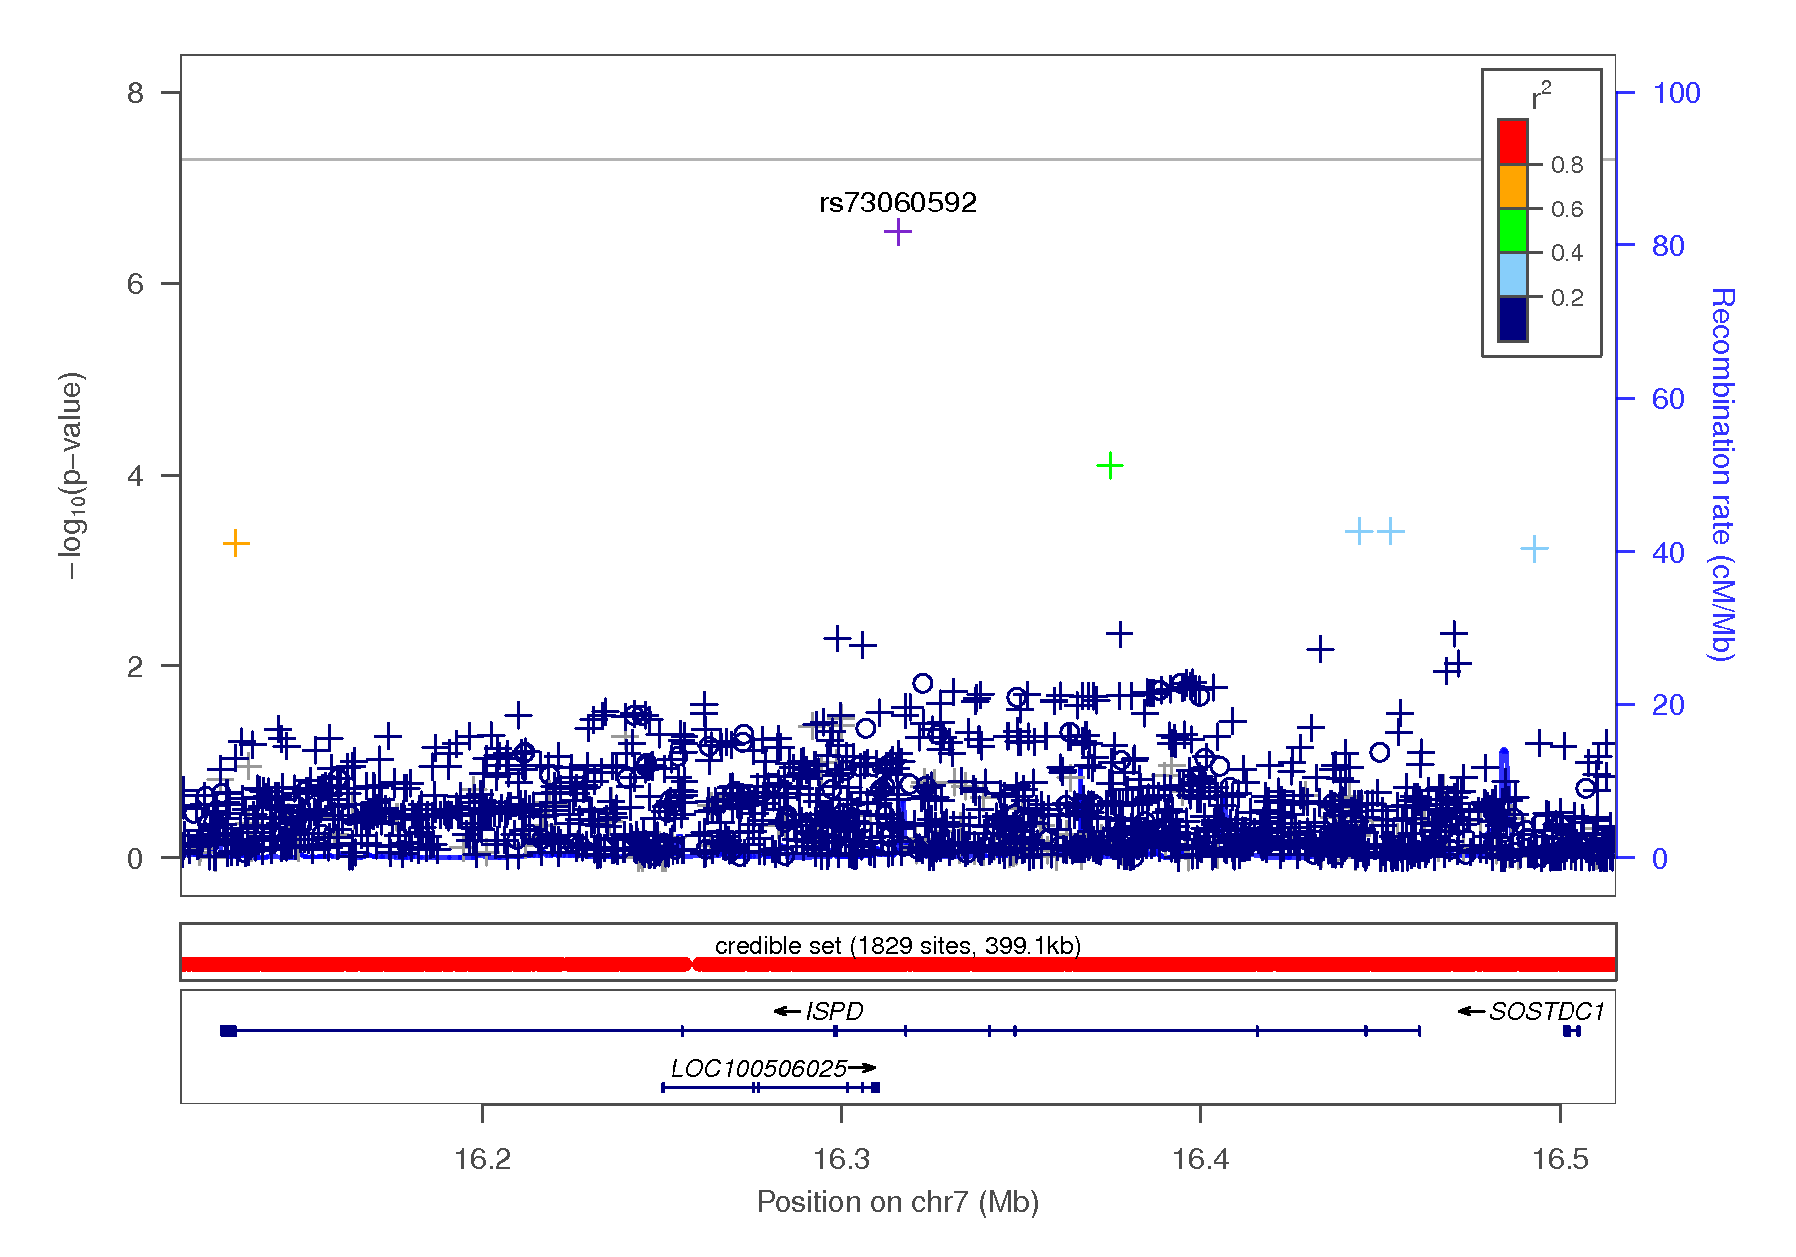
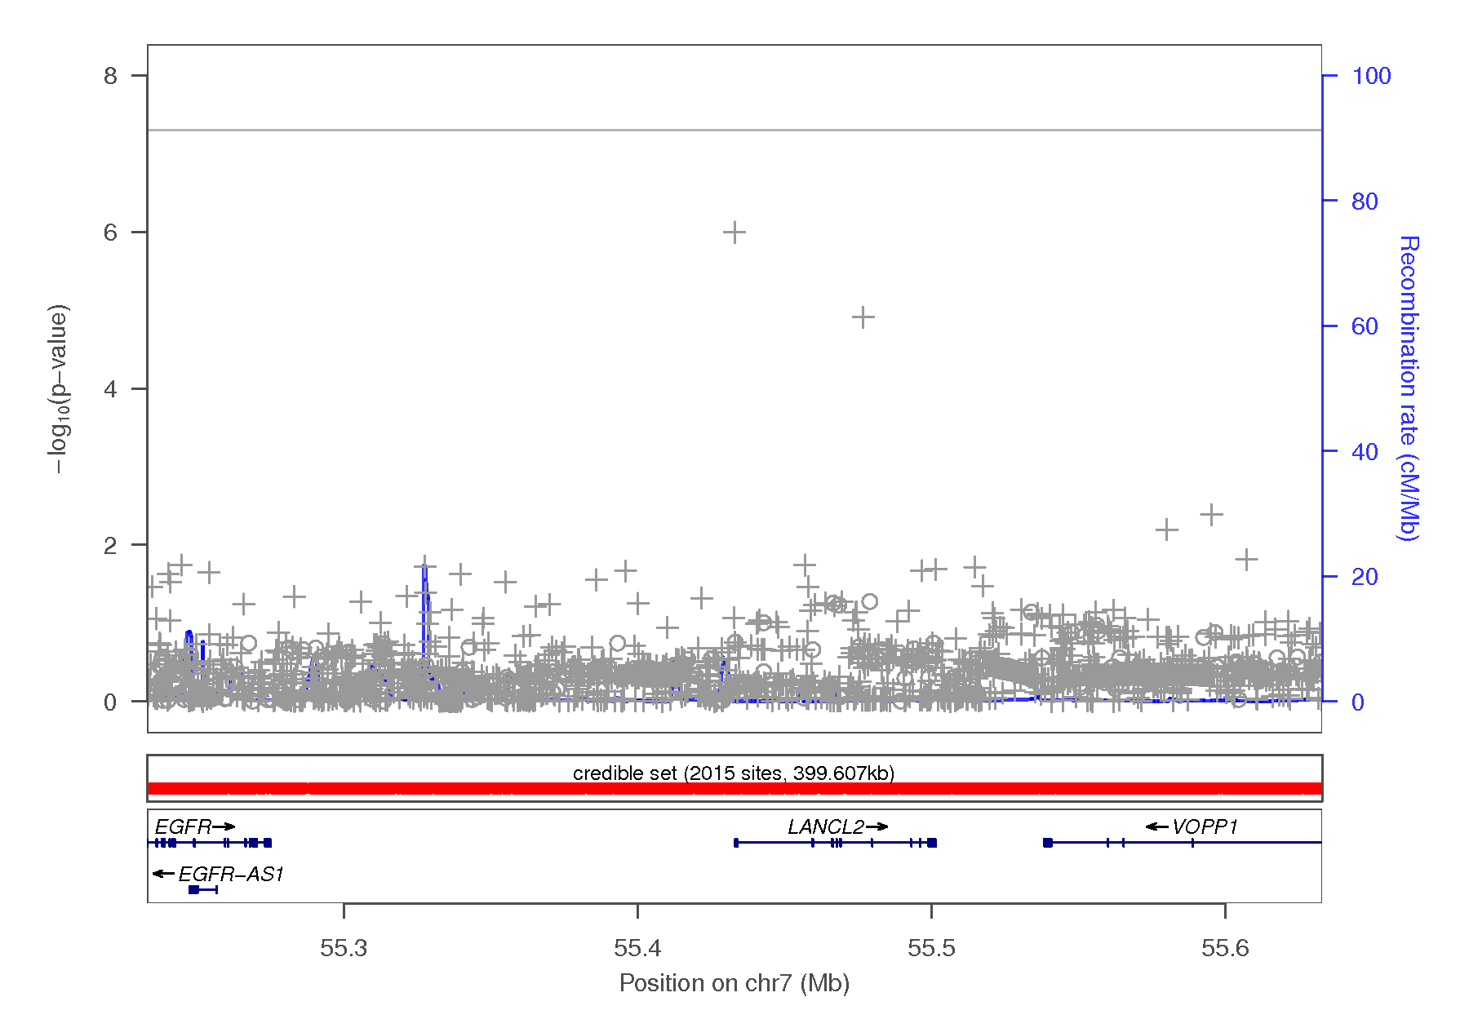
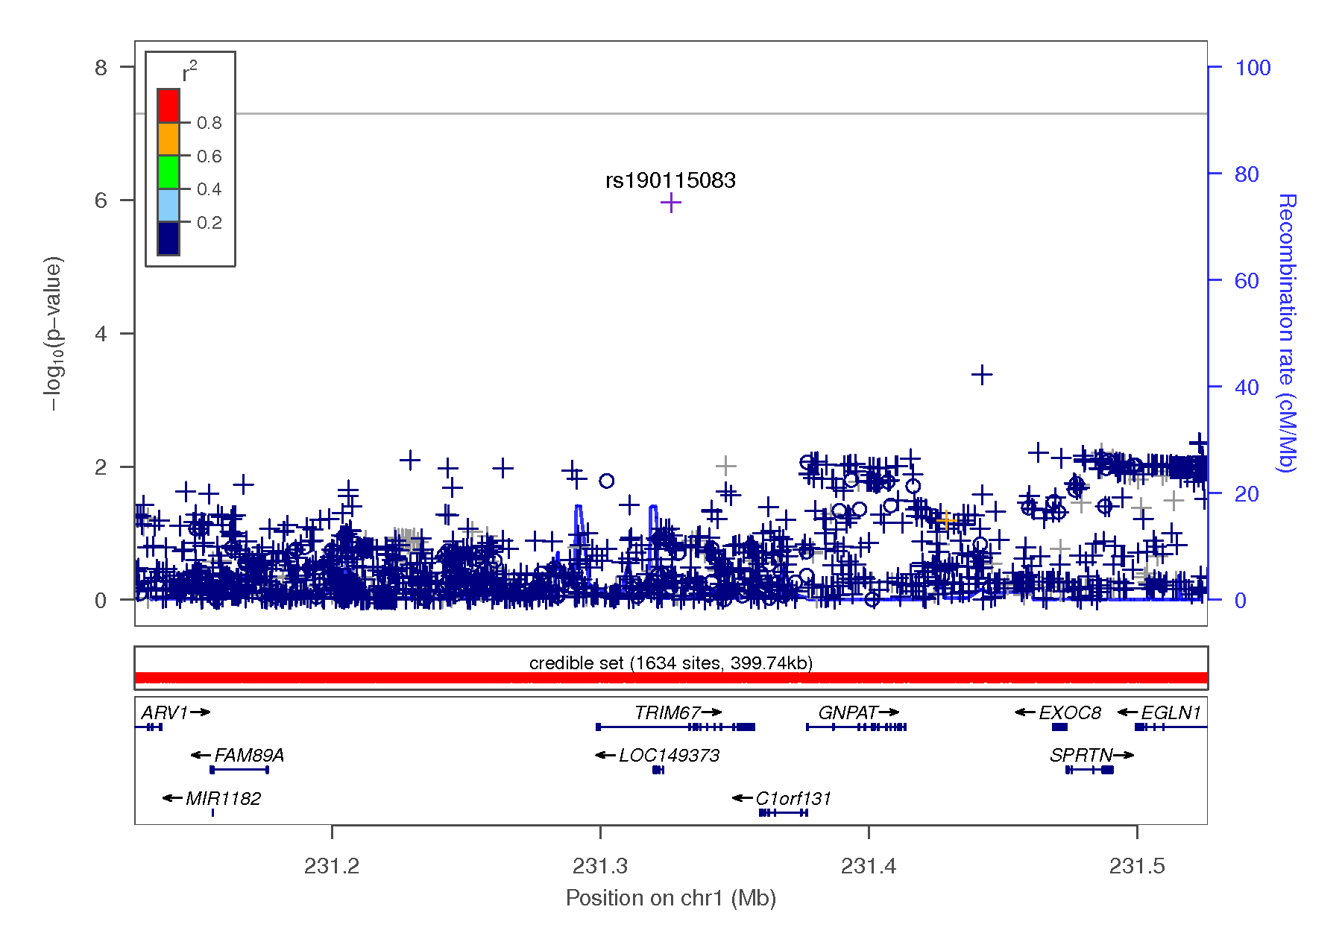
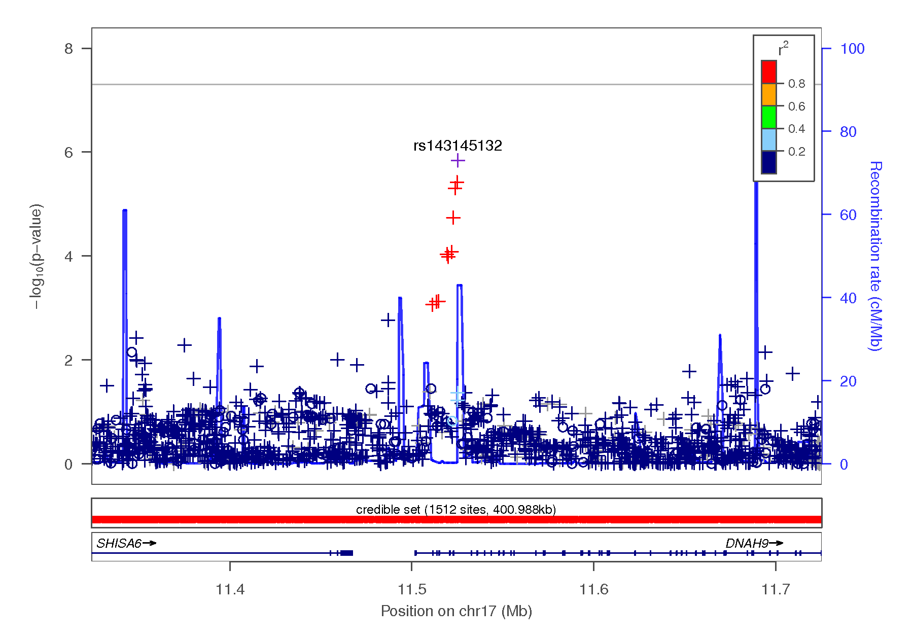

Figure 1-15 Regional association plots focusing on genetic variants associated with BIS attentional scores. This plot was generated using LocusZoom (1). The -log₁₀(P value) is shown on the left y-axis; position in Mb is on the x-axis. Recombination rates (expressed in centiMorgans cM per Mb; NCBI Build GRCh37; highlighted in blue) are shown on the right y-axis. Pairwise linkage disequilibrium (r²) of each SNP with the top SNP in the region is indicated by its color. Crossed points represent imputed SNPs, circles represent directly genotyped SNPs.
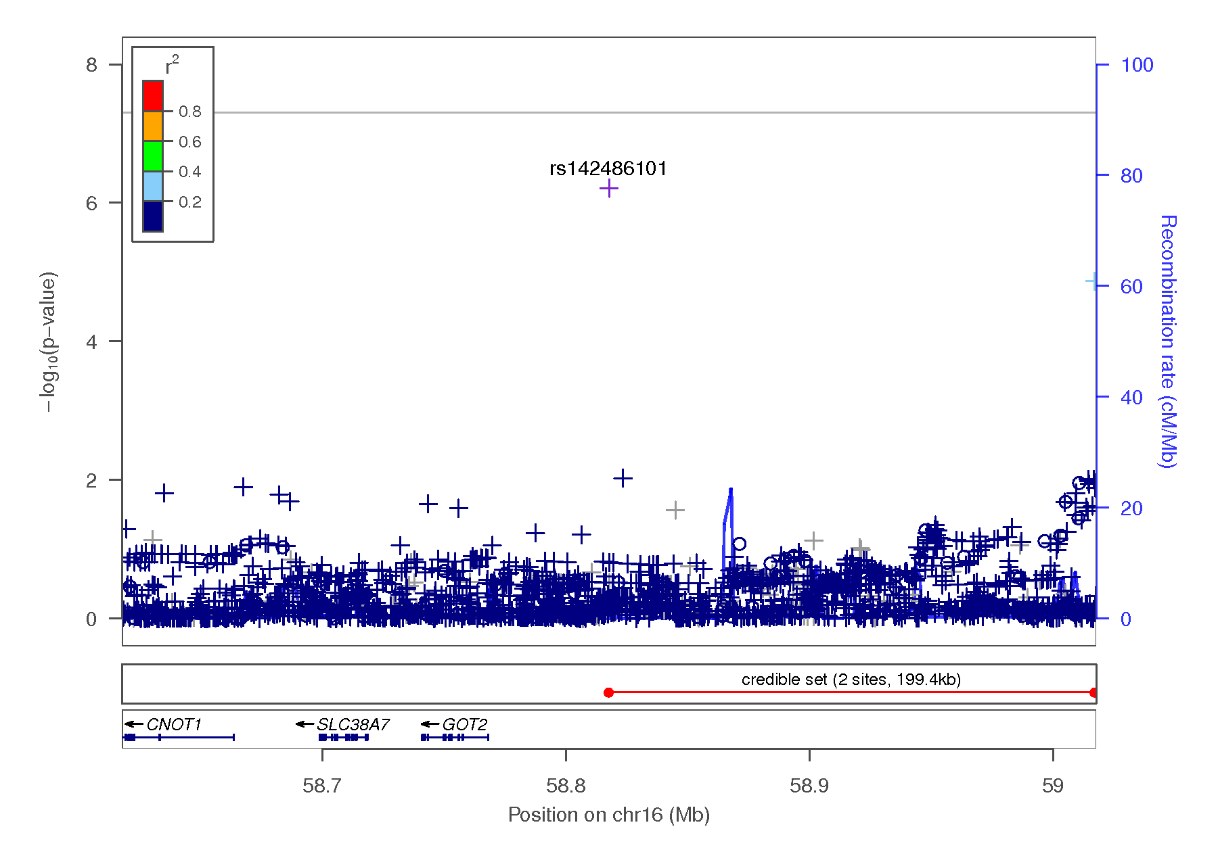
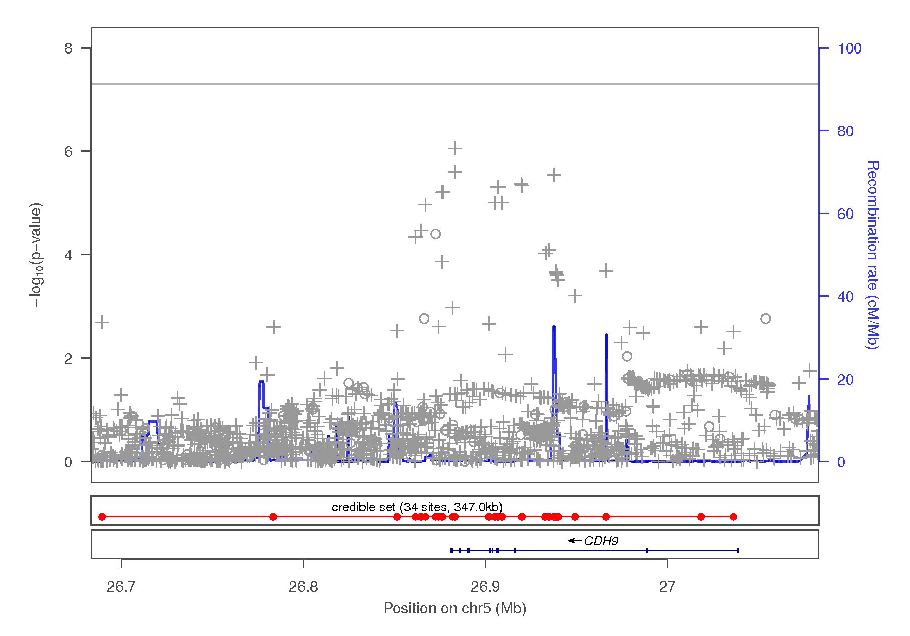
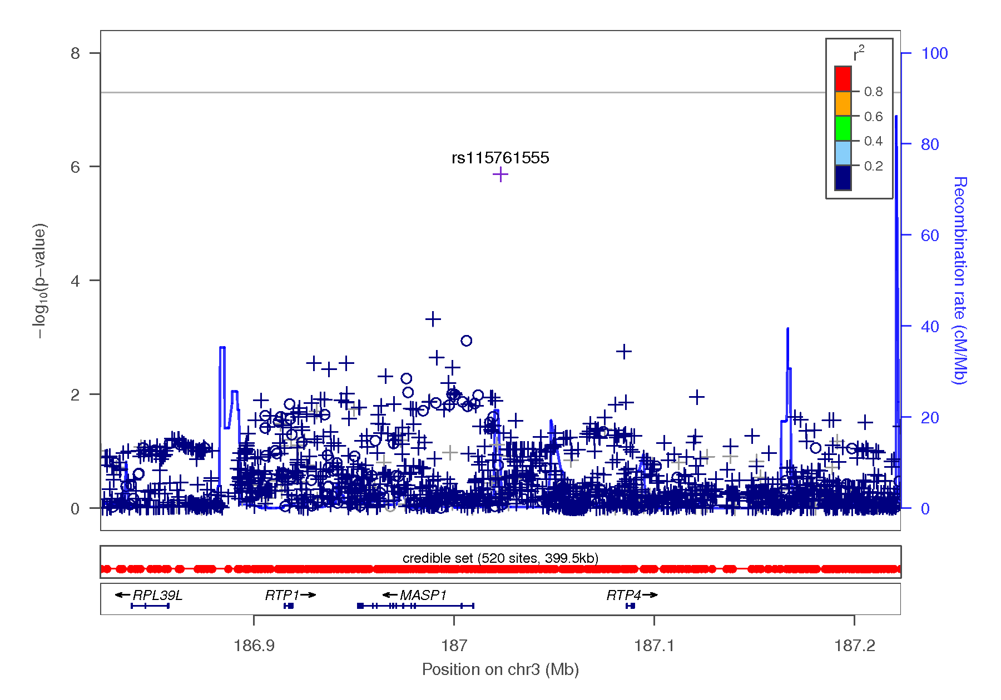
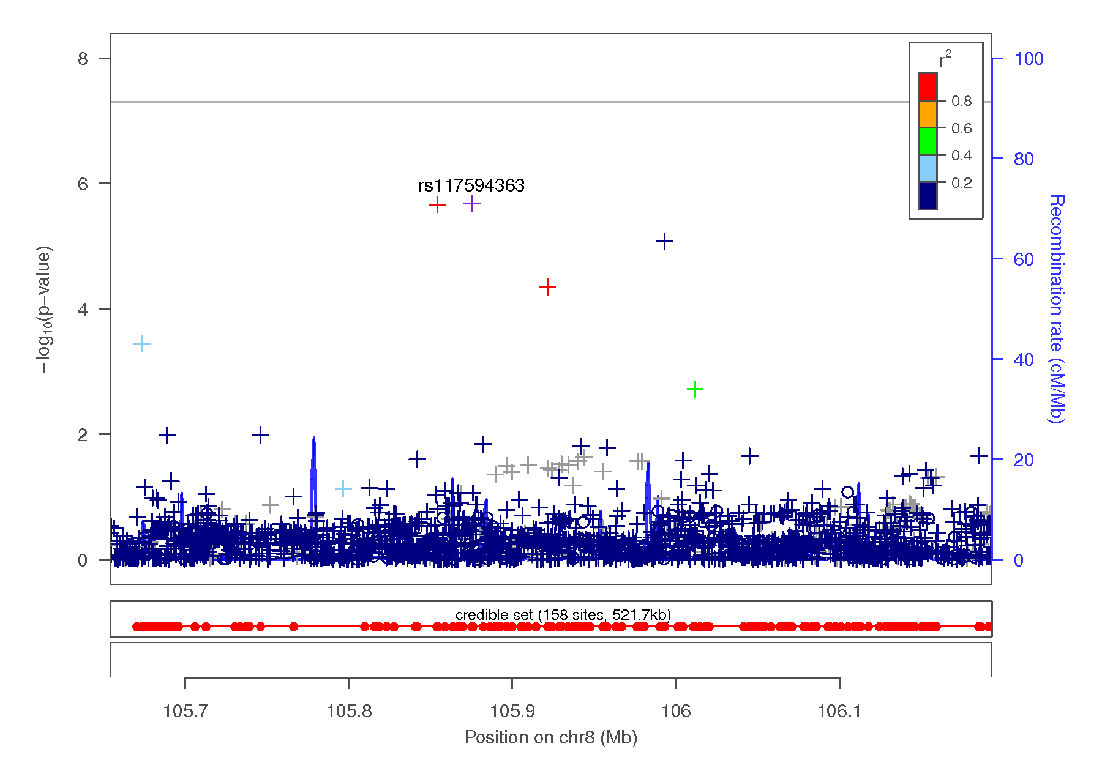
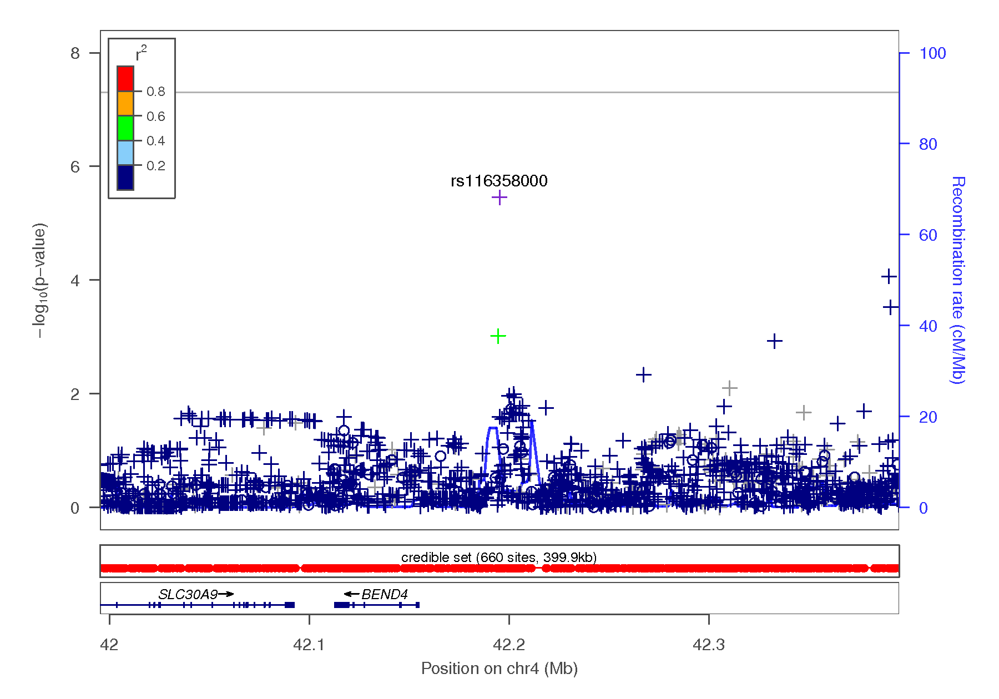

Figure 1-16 Regional association plots focusing on genetic variants associated with BIS motor scores. This plot was generated using LocusZoom (1). The -log₁₀(P value) is shown on the left y-axis; position in Mb is on the x-axis. Recombination rates (expressed in centiMorgans cM per Mb; NCBI Build GRCh37; highlighted in blue) are shown on the right y-axis. Pairwise linkage disequilibrium (r²) of each SNP with the top SNP in the region is indicated by its color. Crossed points represent imputed SNPs, circles represent directly genotyped SNPs.
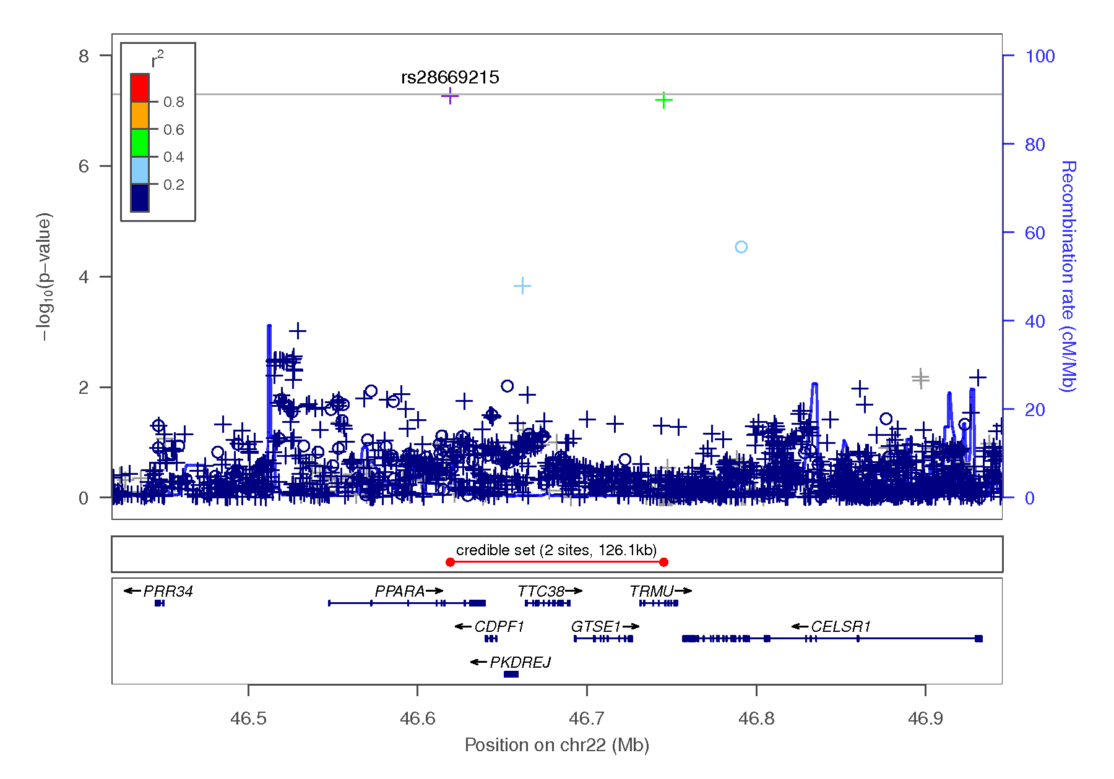
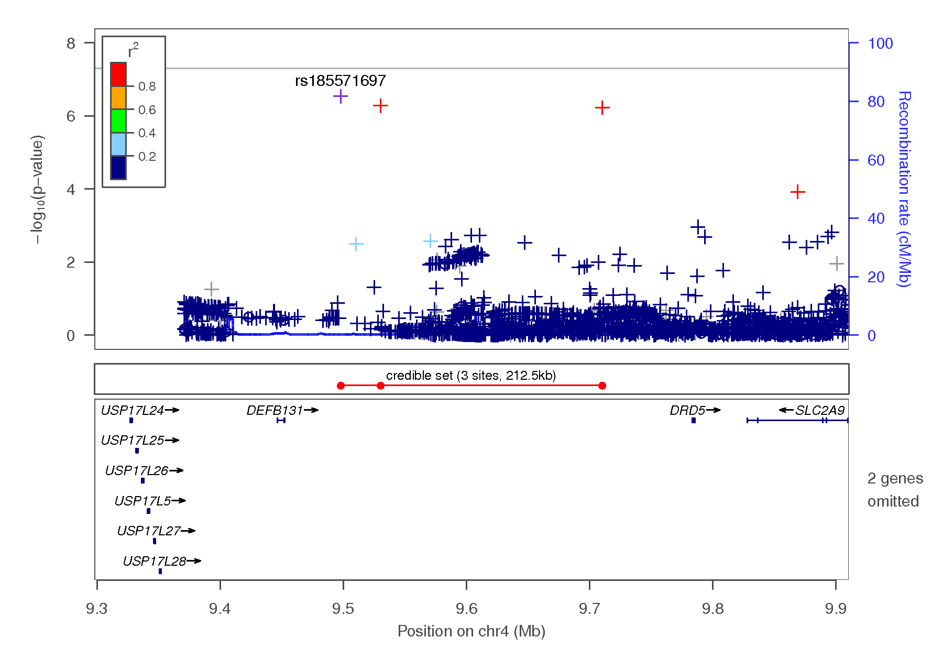
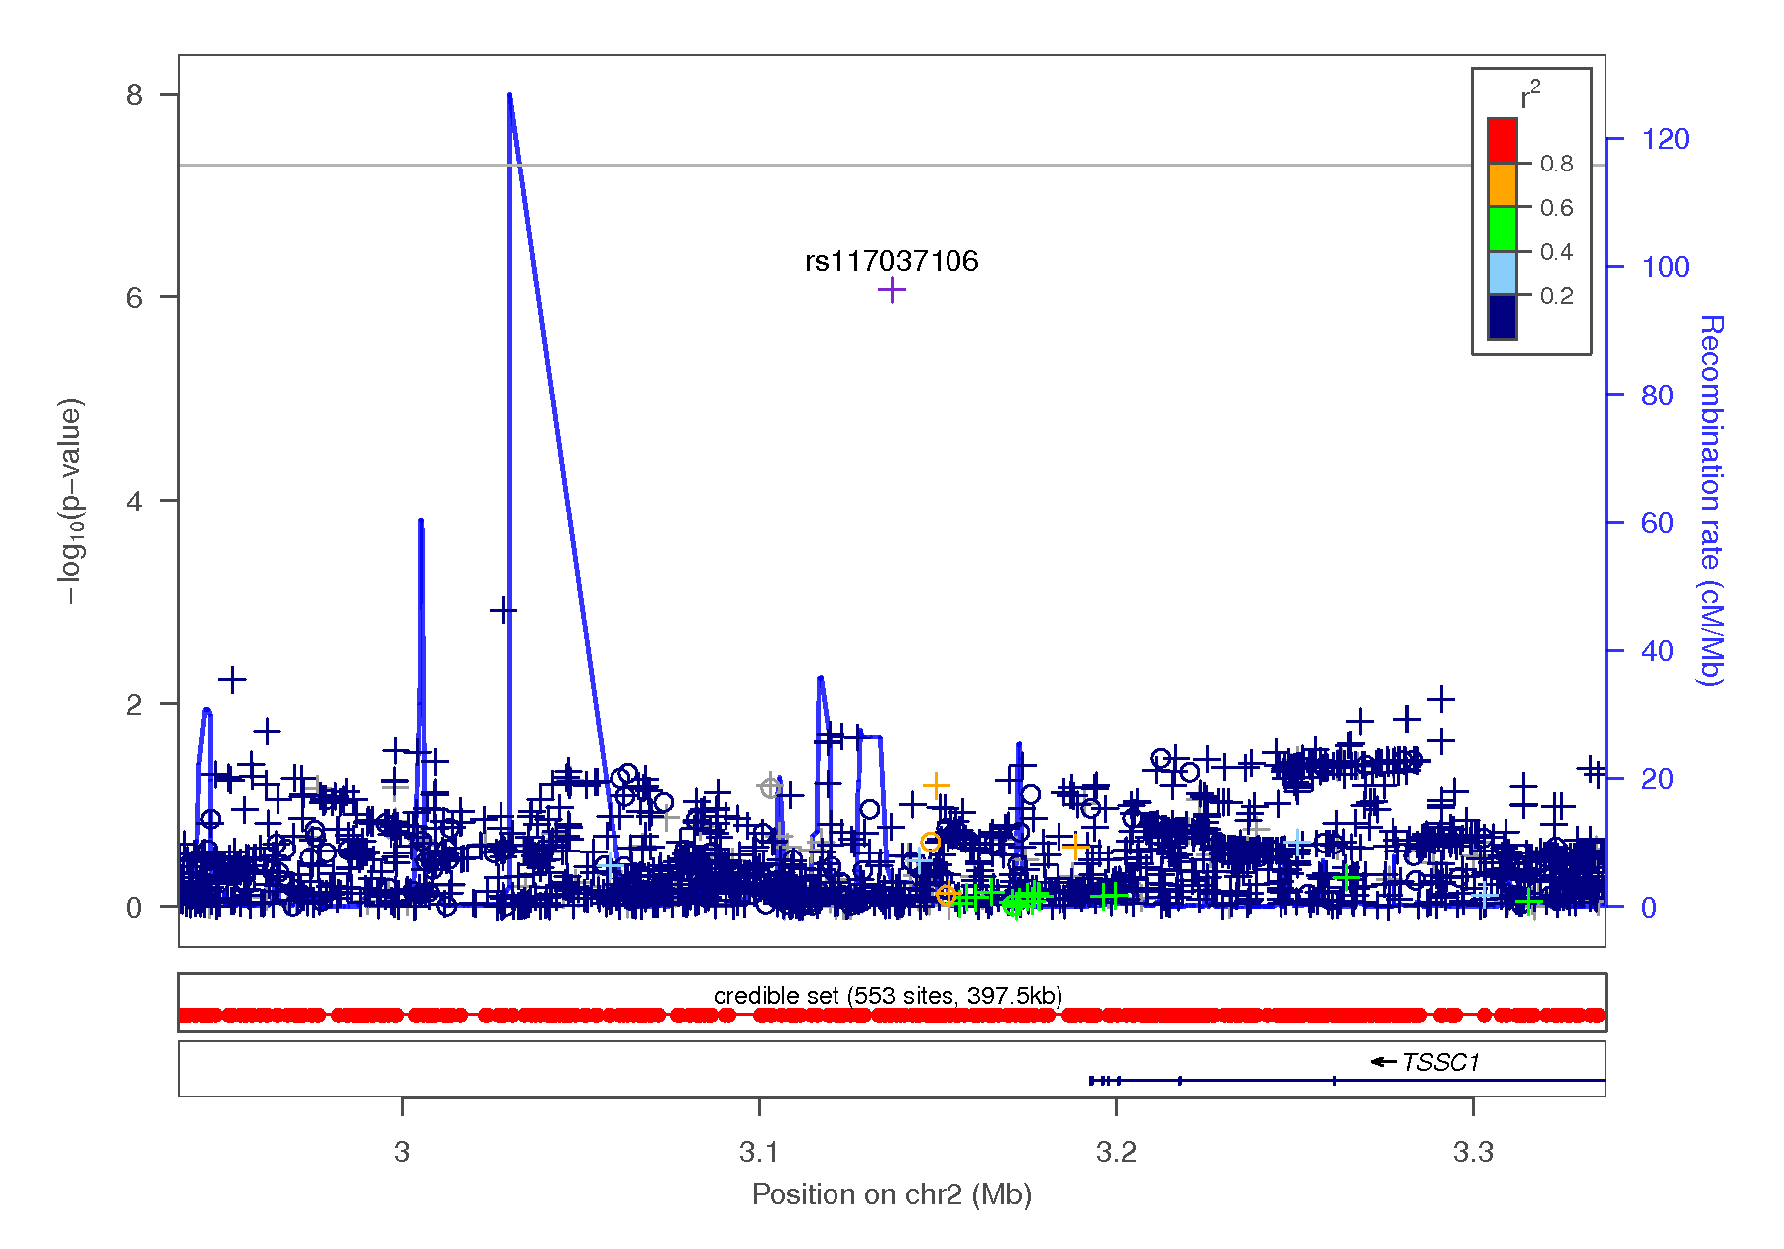
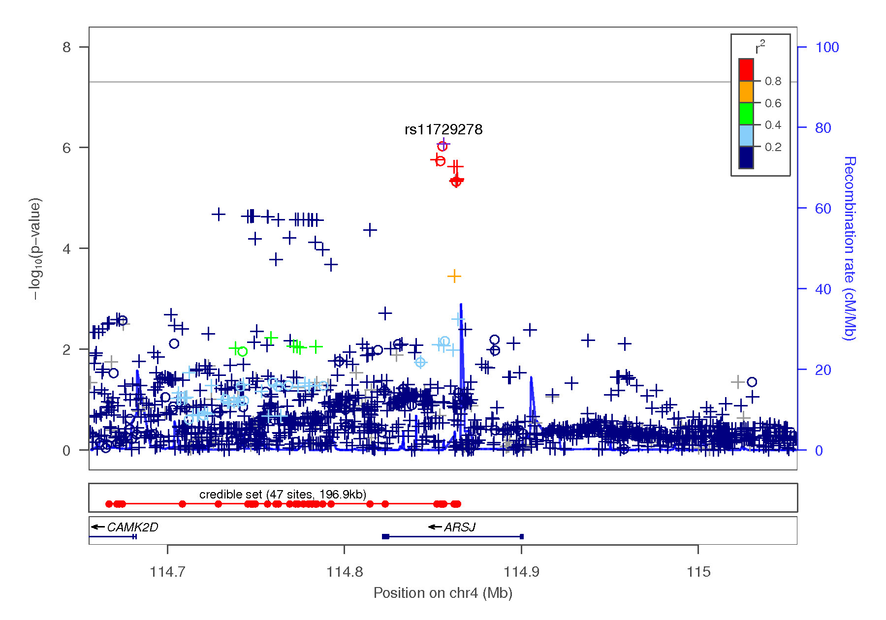
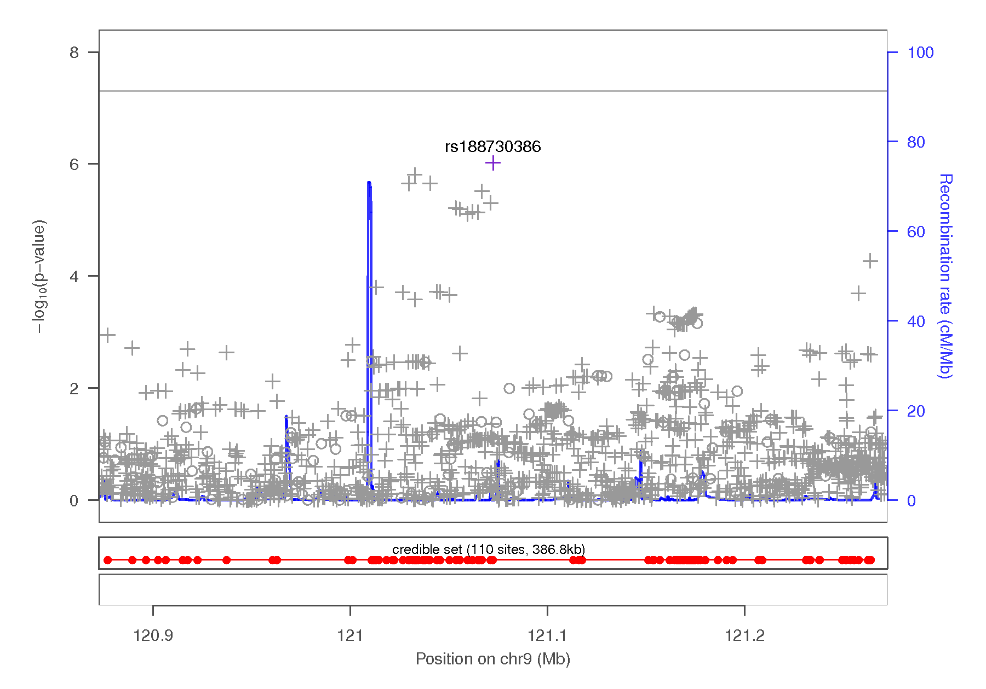

Figure 1-17 Regional association plots focusing on genetic variants associated with BIS nonplanning scores. This plot was generated using LocusZoom (1). The -log₁₀(P value) is shown on the left y-axis; position in Mb is on the x-axis. Recombination rates (expressed in centiMorgans cM per Mb; NCBI Build GRCh37; highlighted in blue) are shown on the right y-axis. Pairwise linkage disequilibrium (r²) of each SNP with the top SNP in the region is indicated by its color. Crossed points represent imputed SNPs, circles represent directly genotyped SNPs.
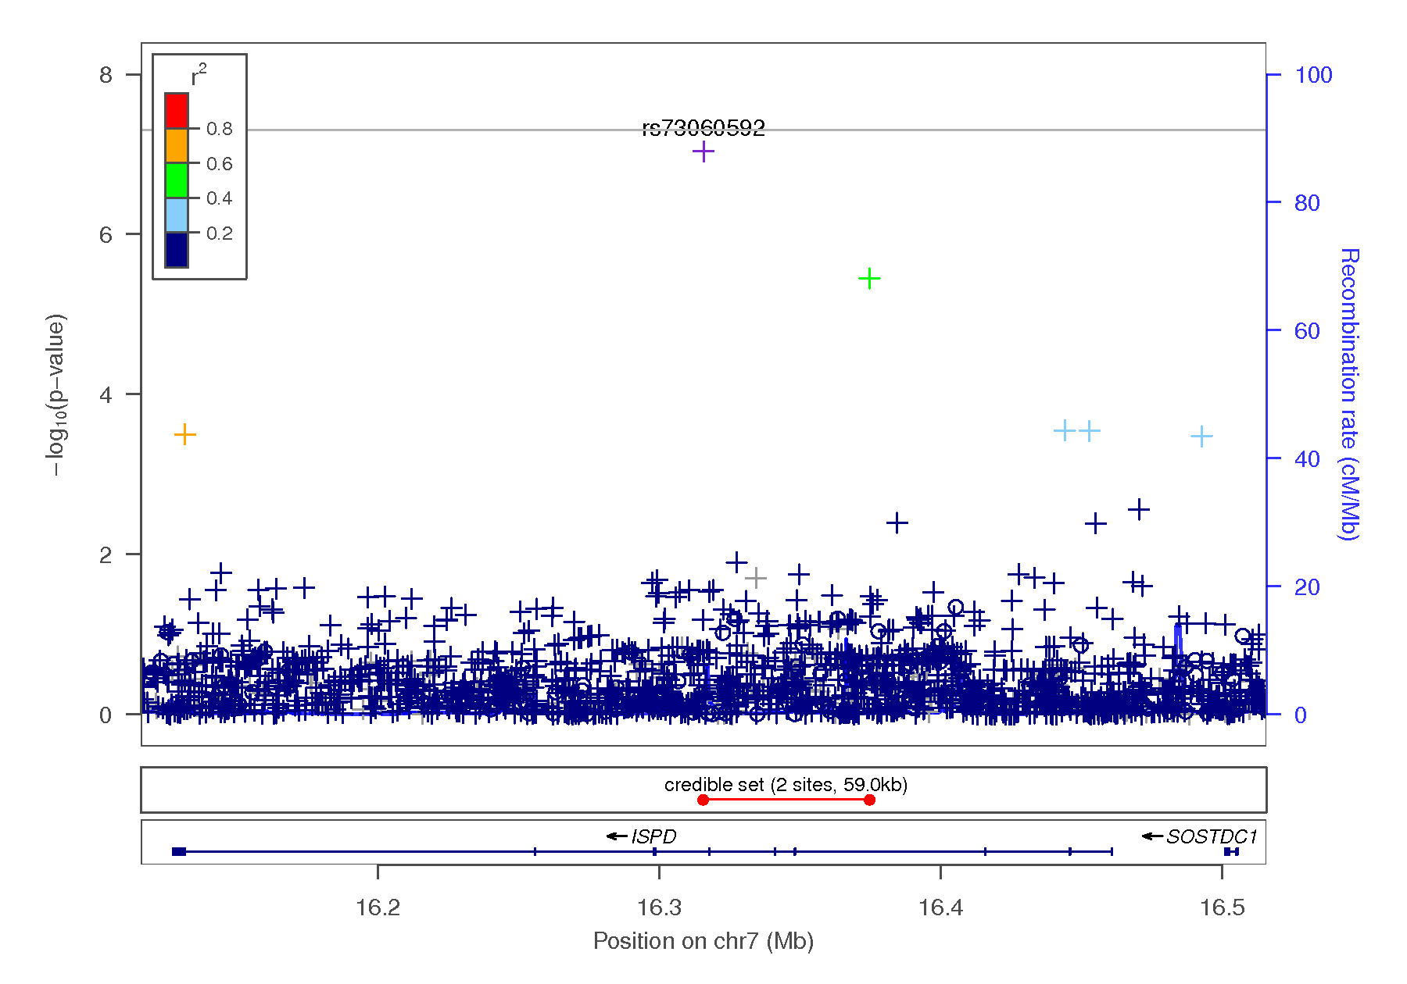
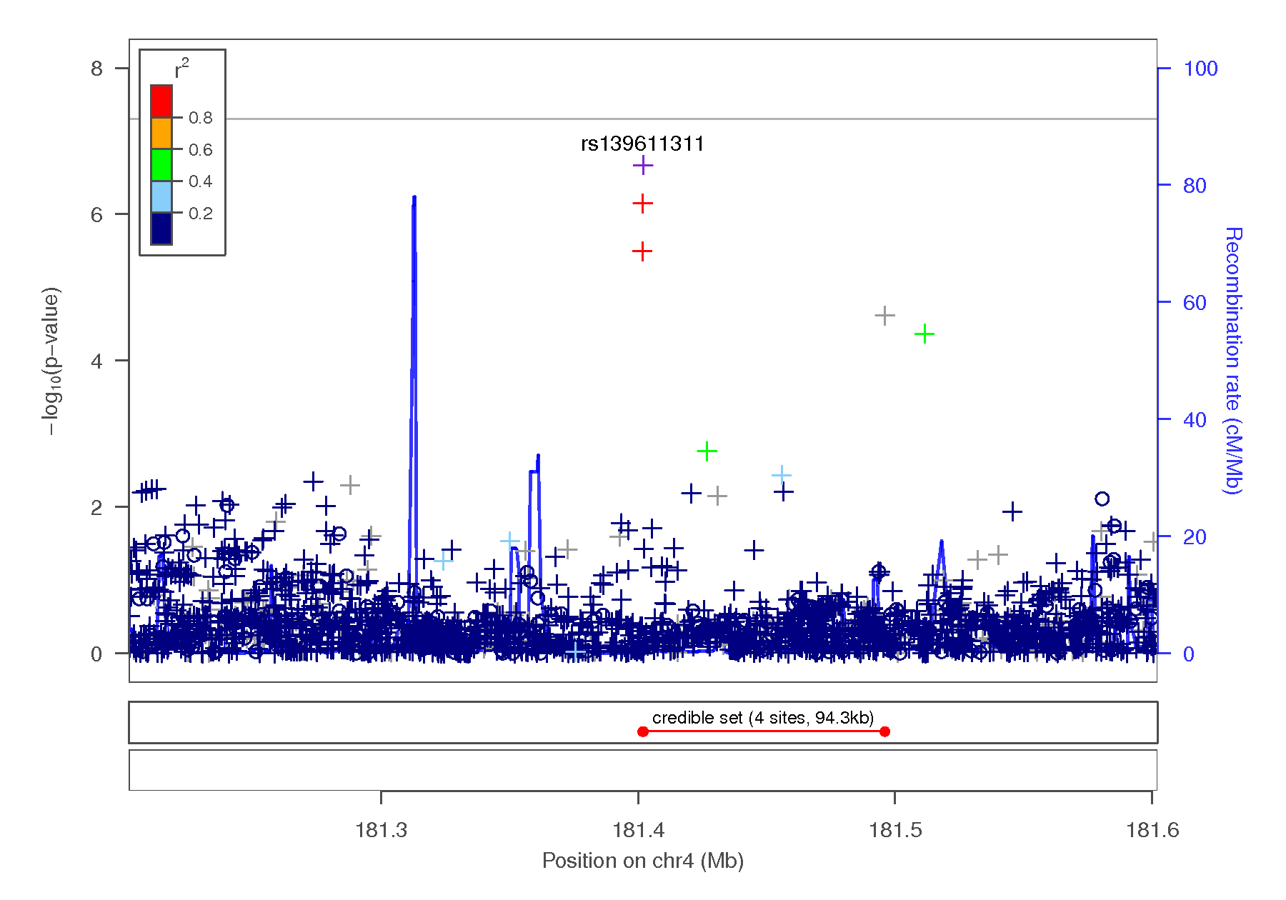
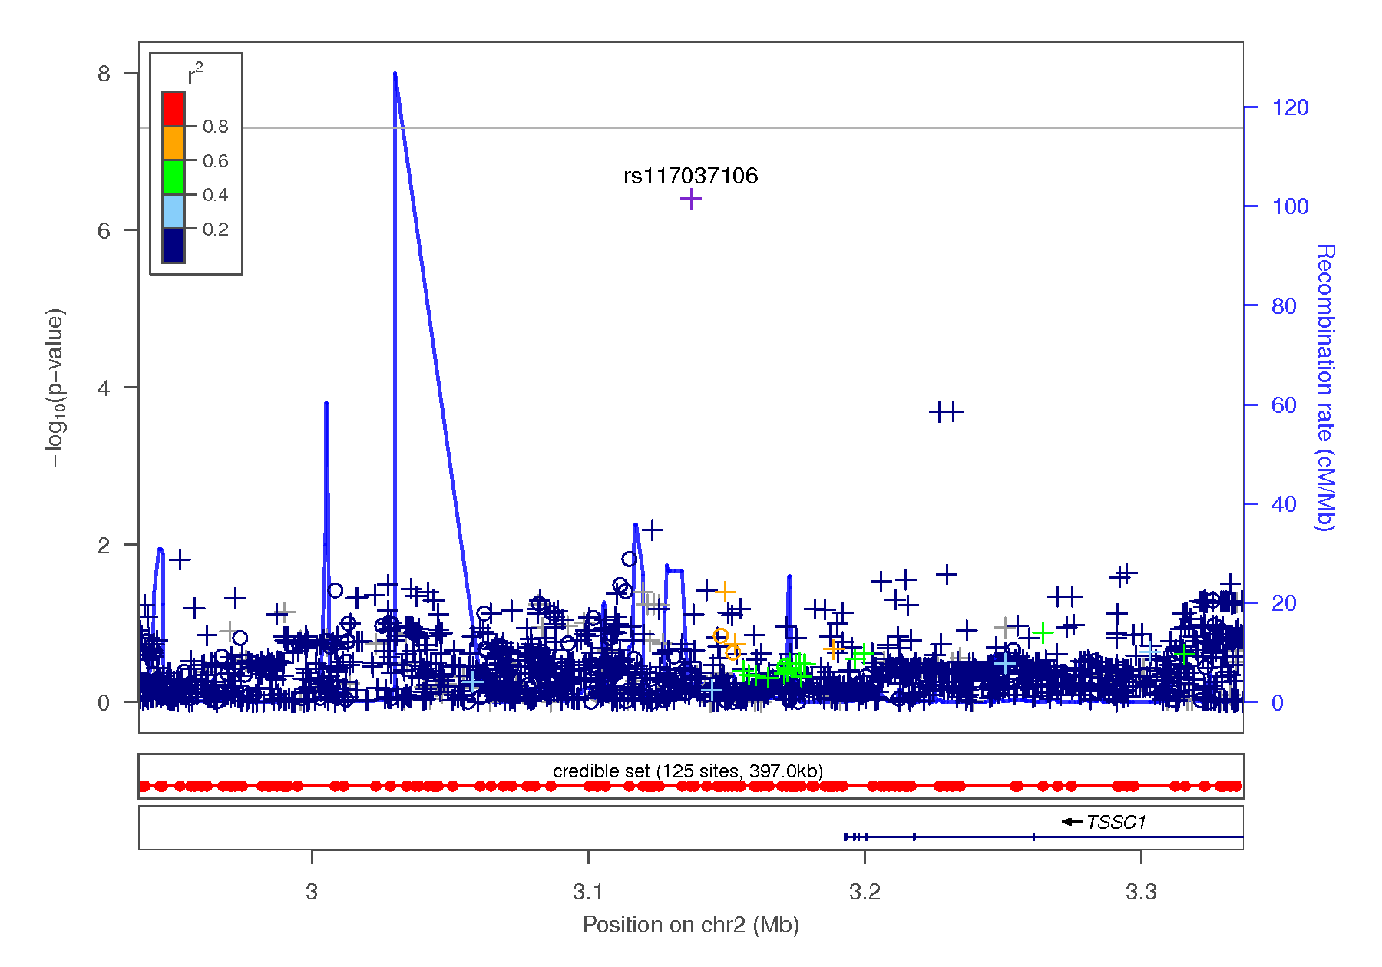
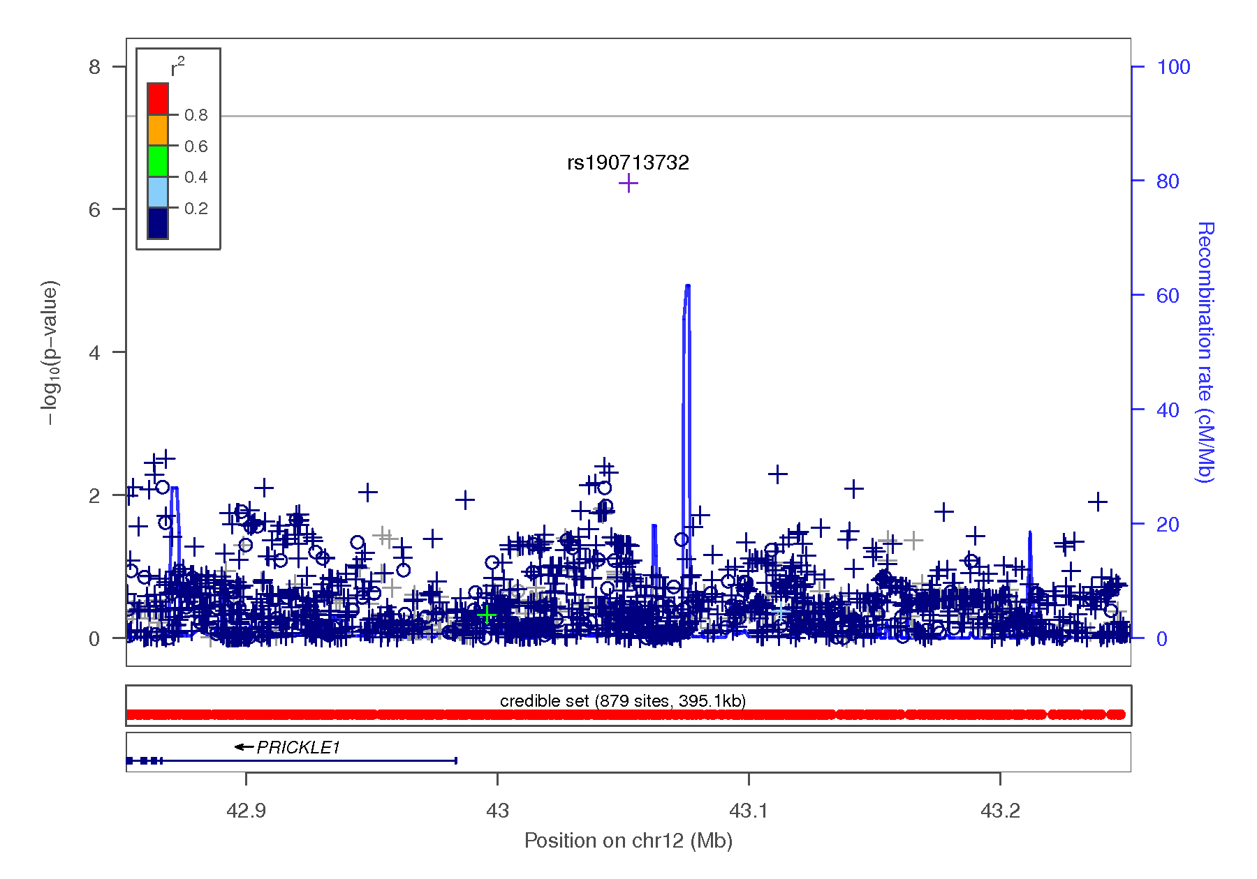
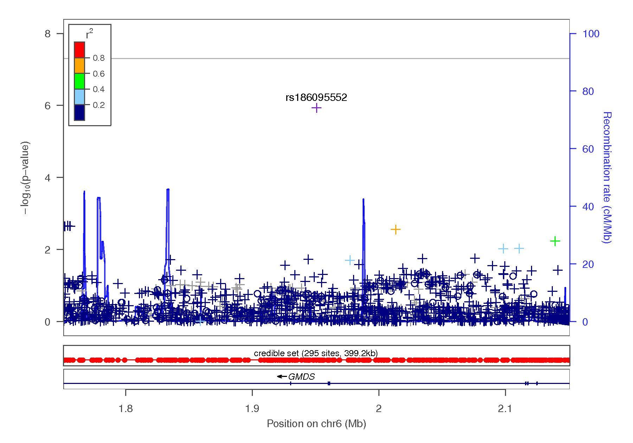

Figure 1-18 Regional association plots focusing on genetic variants associated with drug experimentation. This plot was generated using LocusZoom (1). The -log₁₀(P value) is shown on the left y-axis; position in Mb is on the x-axis. Recombination rates (expressed in centiMorgans cM per Mb; NCBI Build GRCh37; highlighted in blue) are shown on the right y-axis. Pairwise linkage disequilibrium (r²) of each SNP with the top SNP in the region is indicated by its color. Crossed points represent imputed SNPs, circles represent directly genotyped SNPs.
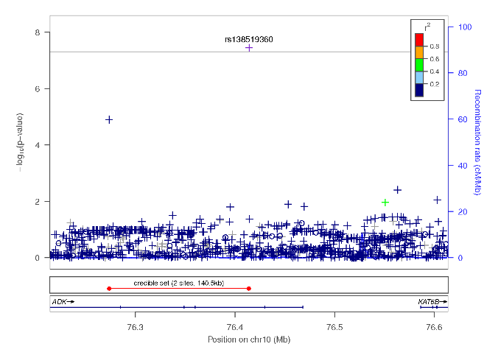
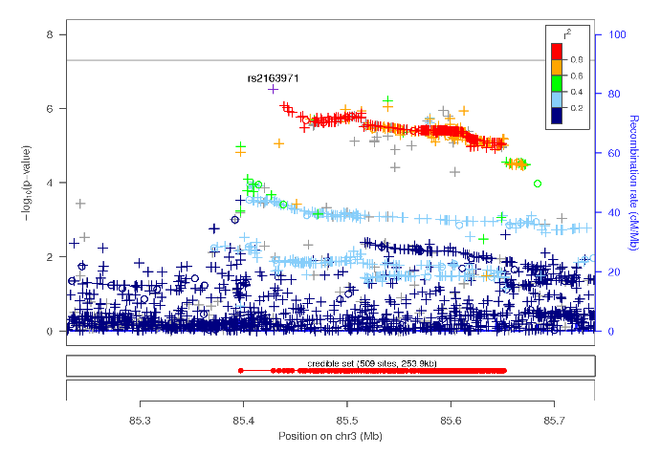
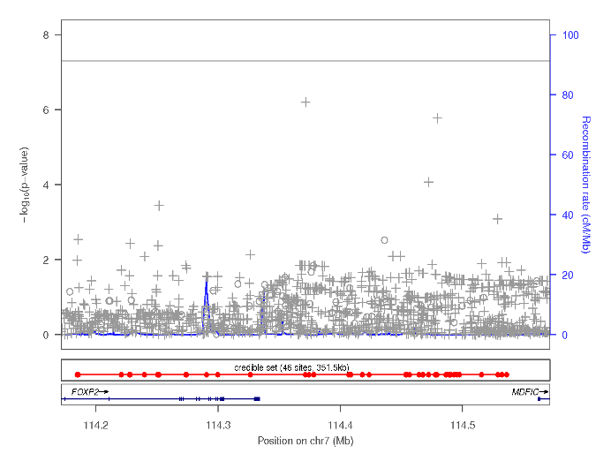
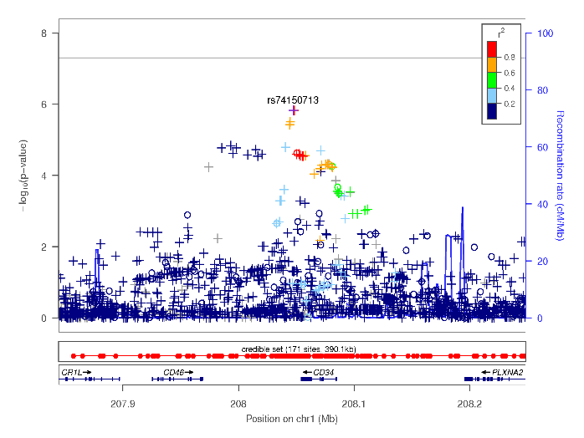
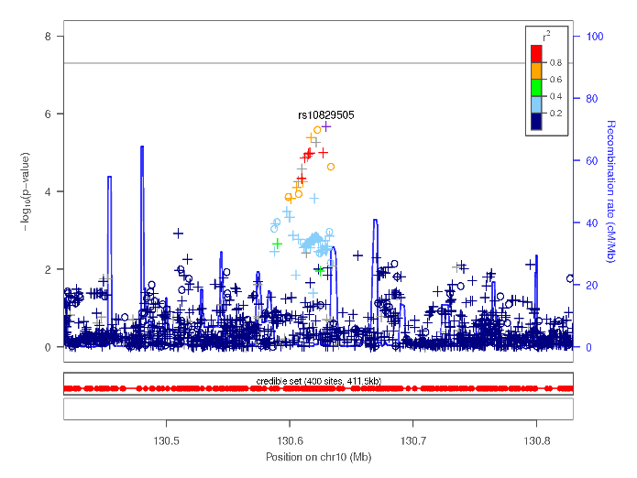

Figure 1-19 Manhattan plot of MAGMA gene-based results indicating the strongest associations between the 22 autosomes, X chromosome, and sensation seeking (a) and drug experimentation (b). Line denotes genome-wide significance (p < 5 x 10⁻⁶). The gene CADM2 was amongst the top hits (a, b; p < 2.65 x 10⁻⁶).
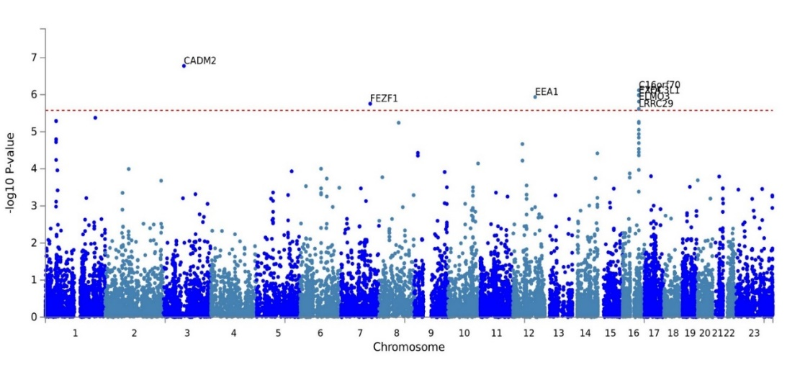
b
a

Figure 2-1 QQ plot of GWAS results indicating the strongest associations between the 22 autosomes, X chromosome, and UPPSP negative urgency. The results have been adjusted for a genomic control inflation factor λ=1.030 (sample size = 22,795).

Figure 2-2 Regional association plots focusing on genetic variants associated with UPPSP negative urgency. This plot was generated using LocusZoom (1). The -log₁₀(P value) is shown on the left y-axis; position in Mb is on the x-axis. Recombination rates (expressed in centiMorgans cM per Mb; NCBI Build GRCh37; highlighted in blue) are shown on the right y-axis. Pairwise linkage disequilibrium (r²) of each SNP with the top SNP in the region is indicated by its color. Crossed points represent imputed SNPs, circles represent directly genotyped SNPs.
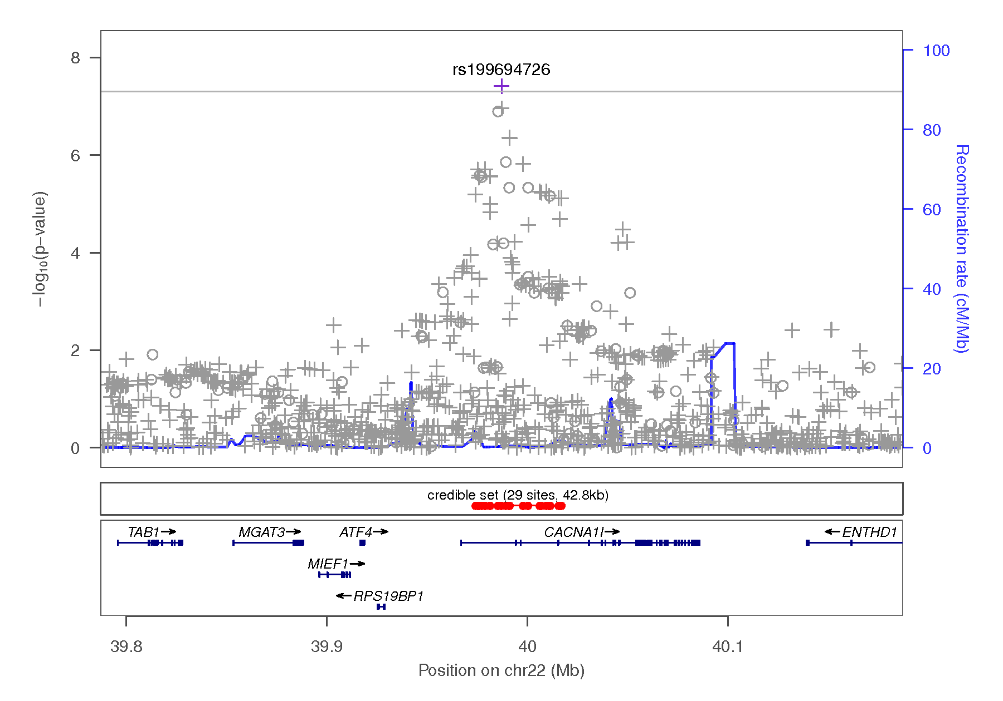
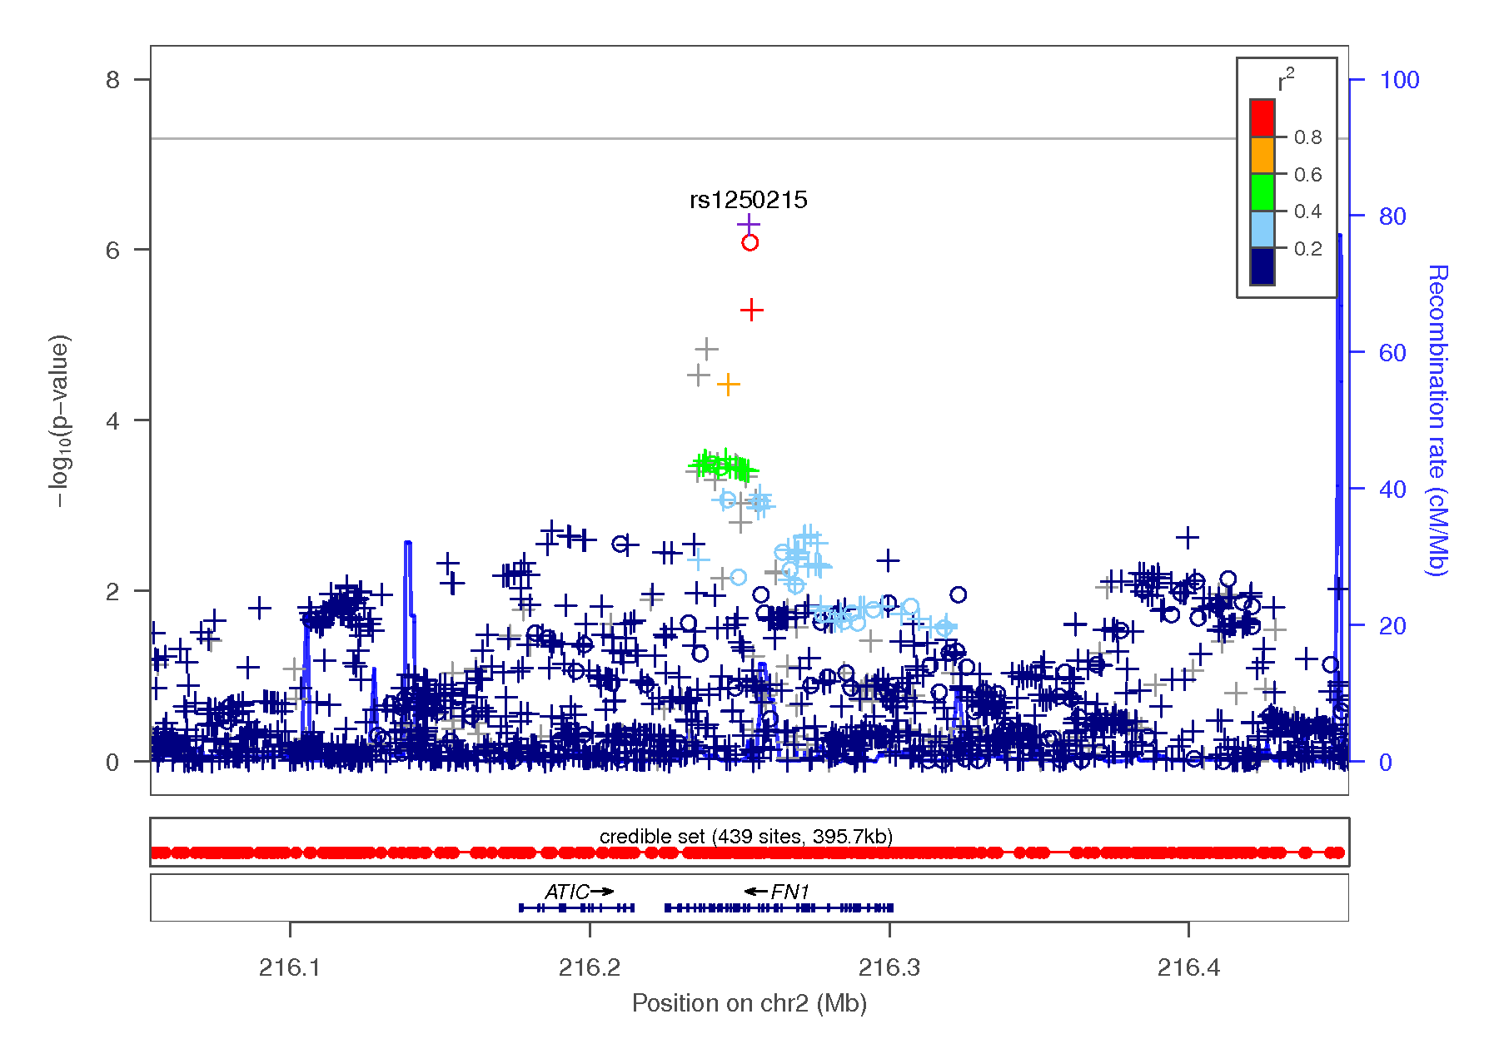
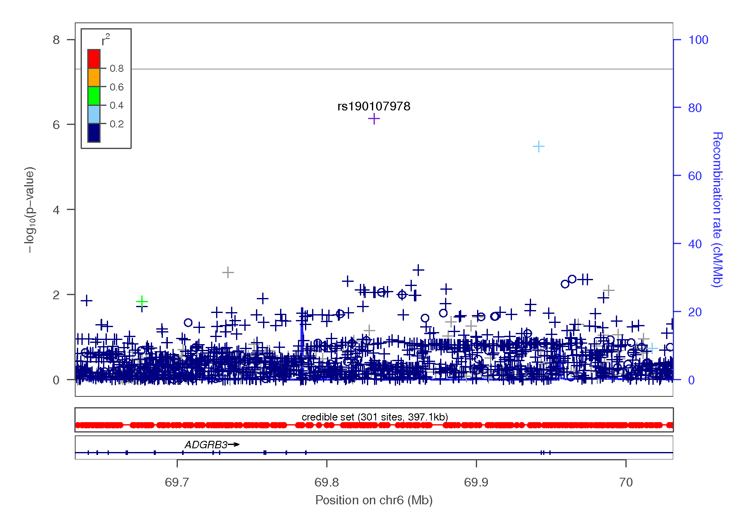
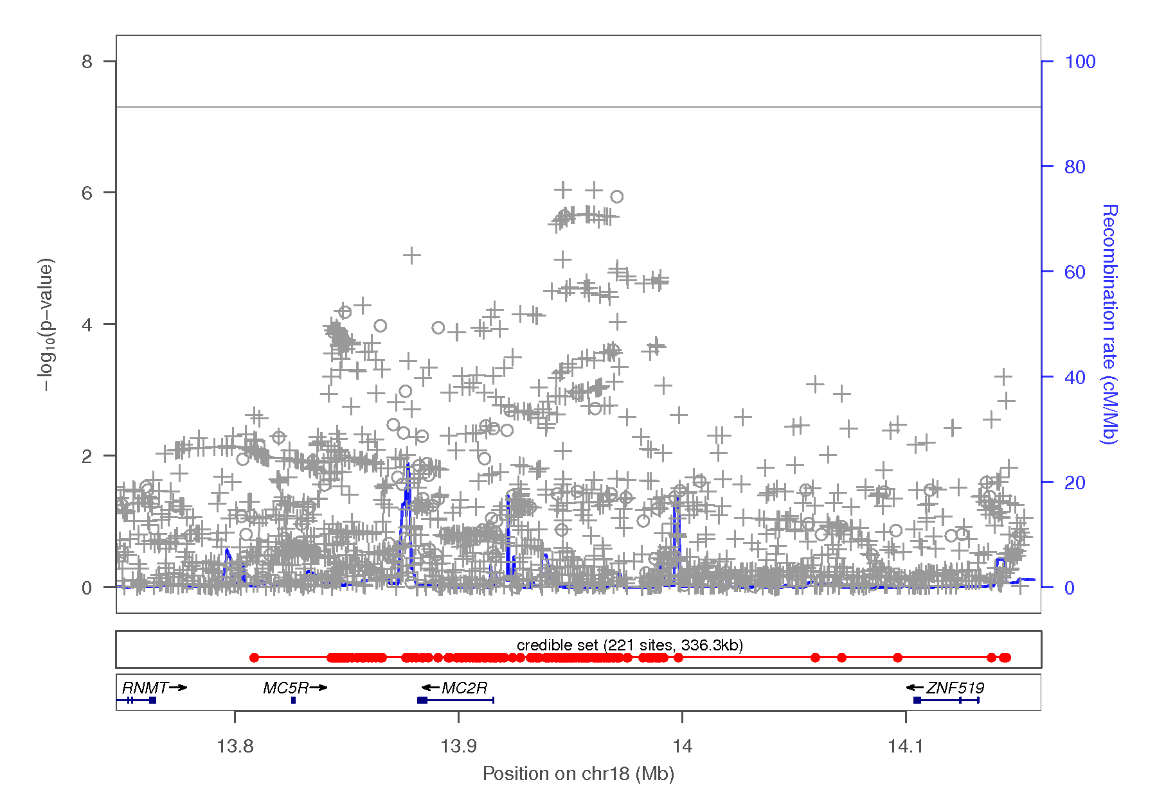
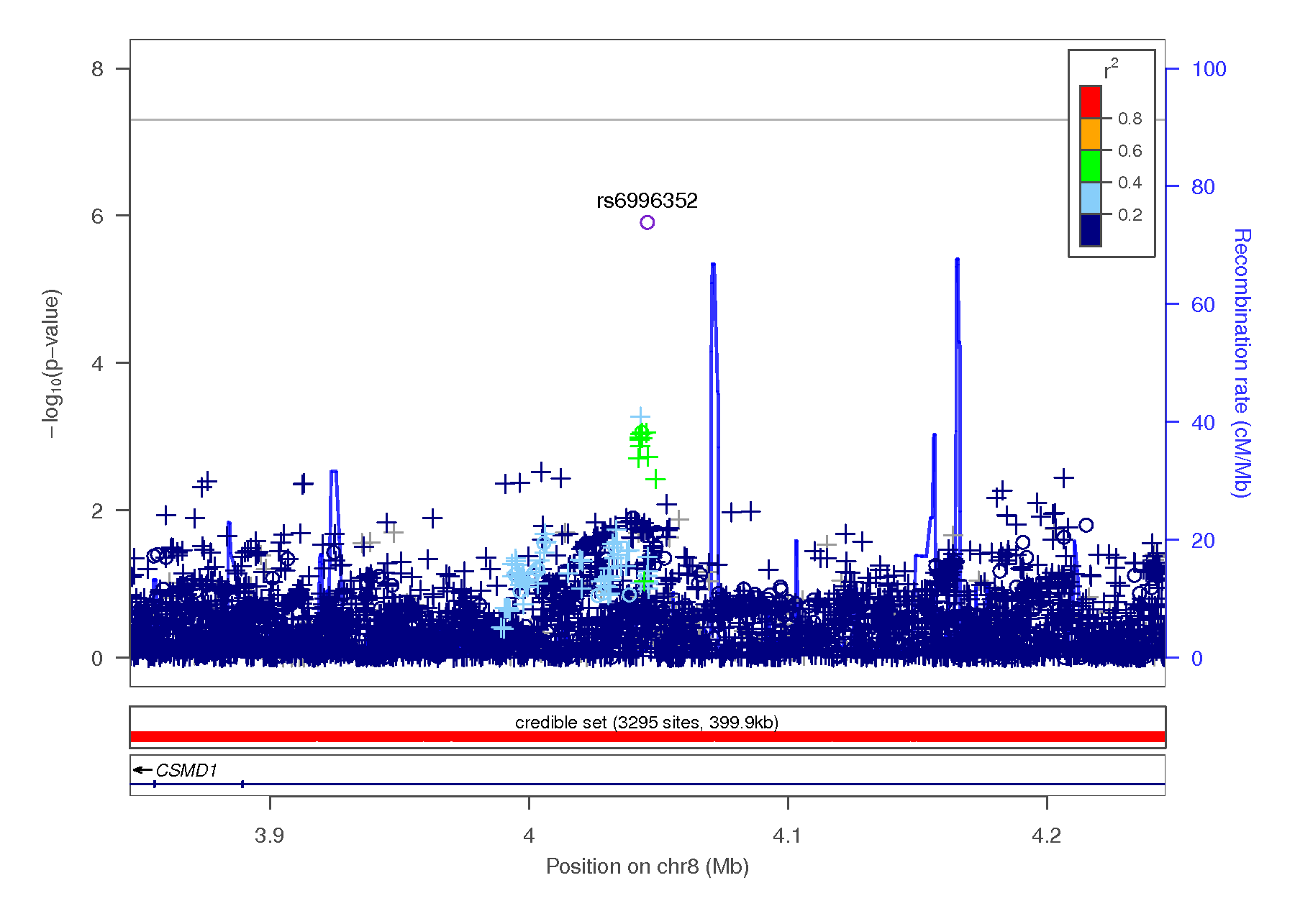

Figure 3-1 Hierarchical clustering (hclust function in R) for impulsivity traits and drug experimentation (23andMe) and other complex and psychiatric traits (independent cohorts). Based on genetic correlations, highly correlated traits are grouped in the same cluster.
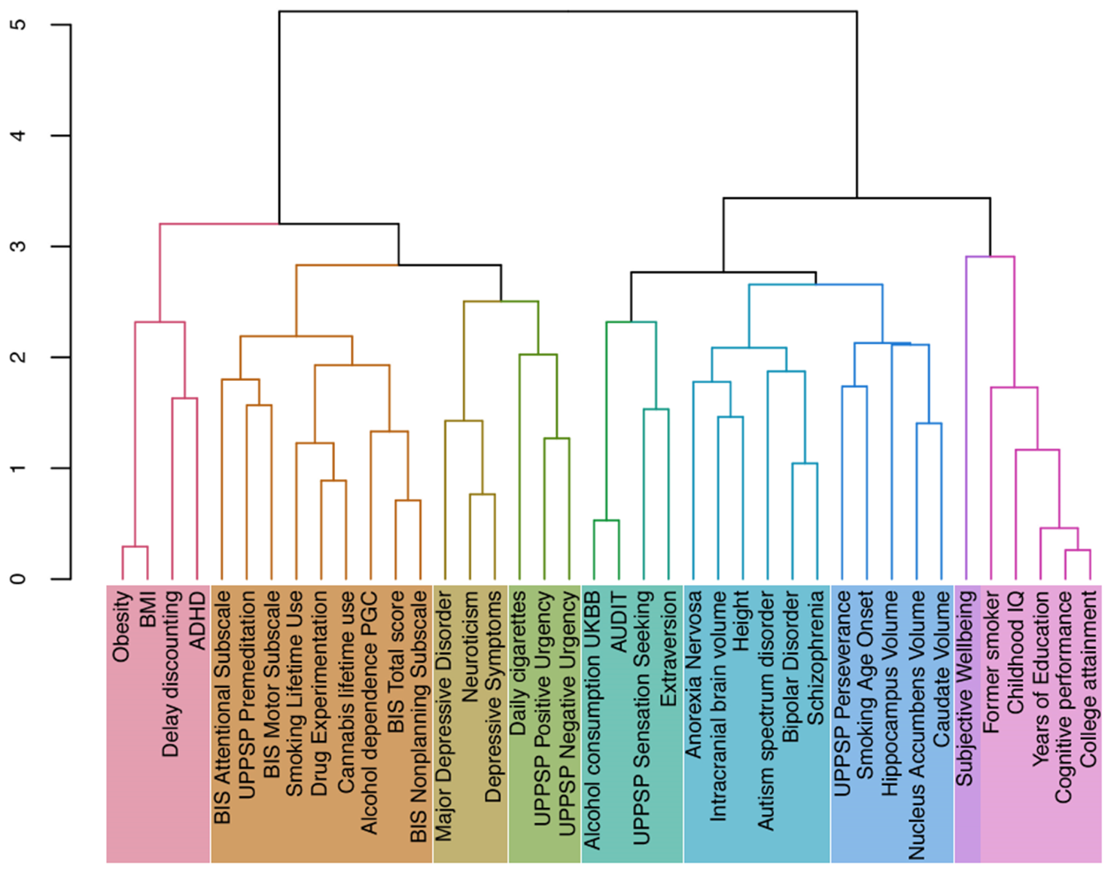

REFERENCES
1. Pruim RJ, Welch RP, Sanna S, Teslovich TM, Chines PS, Gliedt TP, et al. (2010): LocusZoom: regional visualization of genome-wide association scan results. Bioinforma Oxf Engl. 26: 2336–2337.

