Manuscript Title: HIPK2-dependent expression of NMDA receptor subunits regulates survival and cell death in neurons

Authors: Yulei Sheng, Jiasheng Zhang and Eric J. Huang

Files: Extended Data Figures

Extended Data Figure 2-1 | HIPK2 suppresses, whereas MEF2C and HDAC7 do not affect, Grin2a-Luc and Grin2c-Luc reporter activities.
Expression of HIPK2 or c-Jun alone in COS-7 cells was sufficient to suppress the basal activity of Grin2a-Luc and Grin2c-Luc reporters. Unlike c-Jun or HIPK2, transcription factor MEF2C and transcriptional cofactor HDAC7, which interact with HIPK2 and regulate vasculogenesis during embryonic development, had very modest or no detectable effects on the Grin2a-Luc or Grin2c-Luc reporter activity.
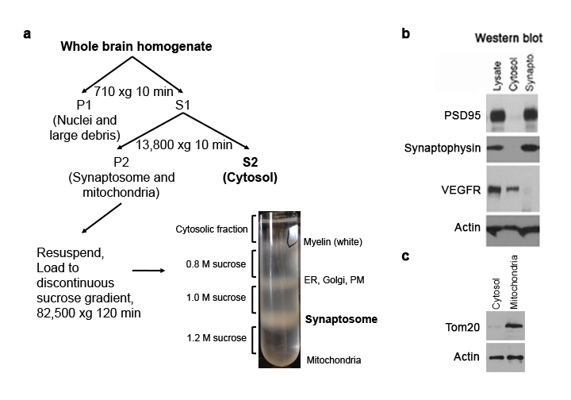

Extended Data Figure 3-1 | Schematic diagram for isolating different subcellular organelles from mouse brain.
(a) Flow chart illustrating the basic steps for the preparation of cytosolic, synaptosomal, and mitochondrial extracts from 2-month-old mice brain. The procedure requires approximately 3 hour from tissue homogenization to collection of the synaptosomal fraction.
(b-c) Western blot showing the purity of the synaptosomal and mitochondrial fractions. PSD95: post-synaptic marker, Synaptophysin: pre-synaptic marker, VEGFR: a membrane associated protein, Tom20: a translocase of the outer membrane in mitochondria, and Actin: ubiquitous expressed protein as loading control.

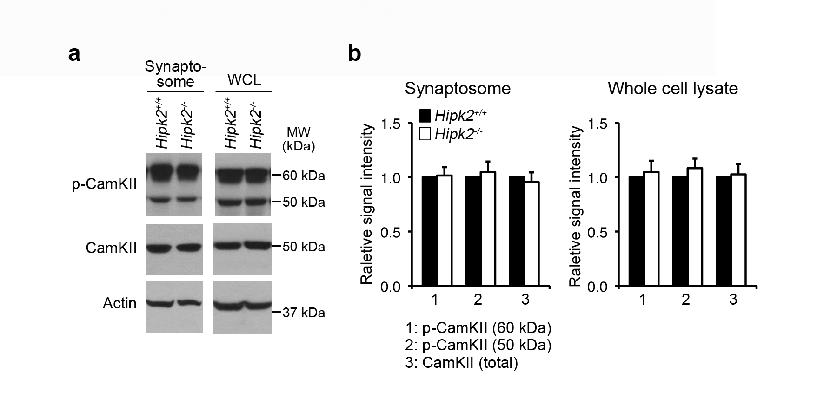

Extended Data Figure 5-1 | Increased relative abundance of GluN2A and the GluN2A/GluN2B ratio in Hipk2^{-/-} mouse brain have no effects on CamKII phosphorylation in synaptosomes.
(a) The western blot results showed that the p-CamKII and total CamKII protein levels in the whole cell lysates, or in synaptosomes isolated from cerebral cortex of Hipk2^{+/+} and Hipk2^{-/-}mice.
(b) The quantification results showed comparable signal intensity for p-CamKII and total CamKII in Hipk2^{+/+} and Hipk2^{-/-} mouse brains. The signal intensity of p-CamKII, total CamKII, and Actin bands was quantified with NIH ImageJ software.

Extended Data Figure 8-1 | Generation of the conditional “knock-in” allele that expresses EGFP-HIPK2 in a Cre-dependent manner.
(a) Step-wise construction of the R26RHIPK2 targeting construct by inserting the loxP-PGKneo-STOP-loxP-EGFP-HIPK2 cassette into the R26R locus using homologous recombination. Cre-mediated recombination removes the loxP-PGKneo-STOP-loxP sequence, leading to the expression of EGFP-HIPK2 in a cell type-specific manner.
(b) Genomic DNA from mouse embryonic stem (ES) cells are analyzed using Southern blots and probes that specifically detect the recombined R26R^{EGFP-HIPK2/+} allele after restriction digestion using the EcoRV enzyme.
(c) Polymerase chain reaction (PCR) using genomic DNA from ES cells to confirm the genotype of R26R^{EGFP-HIPK2/+} allele.

Extended Data Figure 8-2 | Generation of TH-IRES-Cre;R26R^{HIPK2/HIPK2} mice that express additional HIPK2 in DA neurons in the substantia nigra.
(a) A schematic diagram showing the mating scheme to generate conditional knock-in mice that express EGFP-HIPK2 in DA neurons in the substantia nigra by crossing TH-IRES-Cre with R26R^{HIPK2} mice.
(b) Quantitative RT-PCR (QRT-PCR) to detect the relative abundance of Hipk2 mRNA in microdissected substantia nigra tissues from 2 months old wild type (Hipk2^{+/+}), Hipk2^{-/-} and TH-IRES-Cre;R26R^{HIPK2/HIPK2} mice. The results show that the substantia nigra of TH-IRES-Cre;R26R^{HIPK2/HIPK2} mice contain about 50% increase of Hipk2 mRNA, whereas there is no Hipk2 mRNA detected in the substantia nigra of Hipk2^{-/-} mice.
(c) Western blots using tissues dissected from the substantia nigra of wild type (Hipk2^{+/+}), Hipk2^{-/-}, R26R^{HIPK2/+}, R26R^{HIPK2/HIPK2}, TH-IRES-Cre;R26R^{HIPK2/+} and TH-IRES-Cre;R26R^{HIPK2/HIPK2} mice. Anti-GFP antibody can detect low level of EGFP-tagged HIPK2 fusion proteins in the substantia nigra of TH-IRES-Cre;R26R^{HIPK2/+} and TH-IRES-Cre;R26R^{HIPK2/HIPK2} mice.
(d-e) Immunofluorescent confocal microscopy using anti-tyrosine hydroxylase (TH) and anti-GFP antibodies in the substantia nigra of R26R^{HIPK2/HIPK2} and TH-IRES-Cre;R26R^{HIPK2/HIPK2} mice. Scale bar in panel d is 40 μm and in panel d’ 8 μm.

