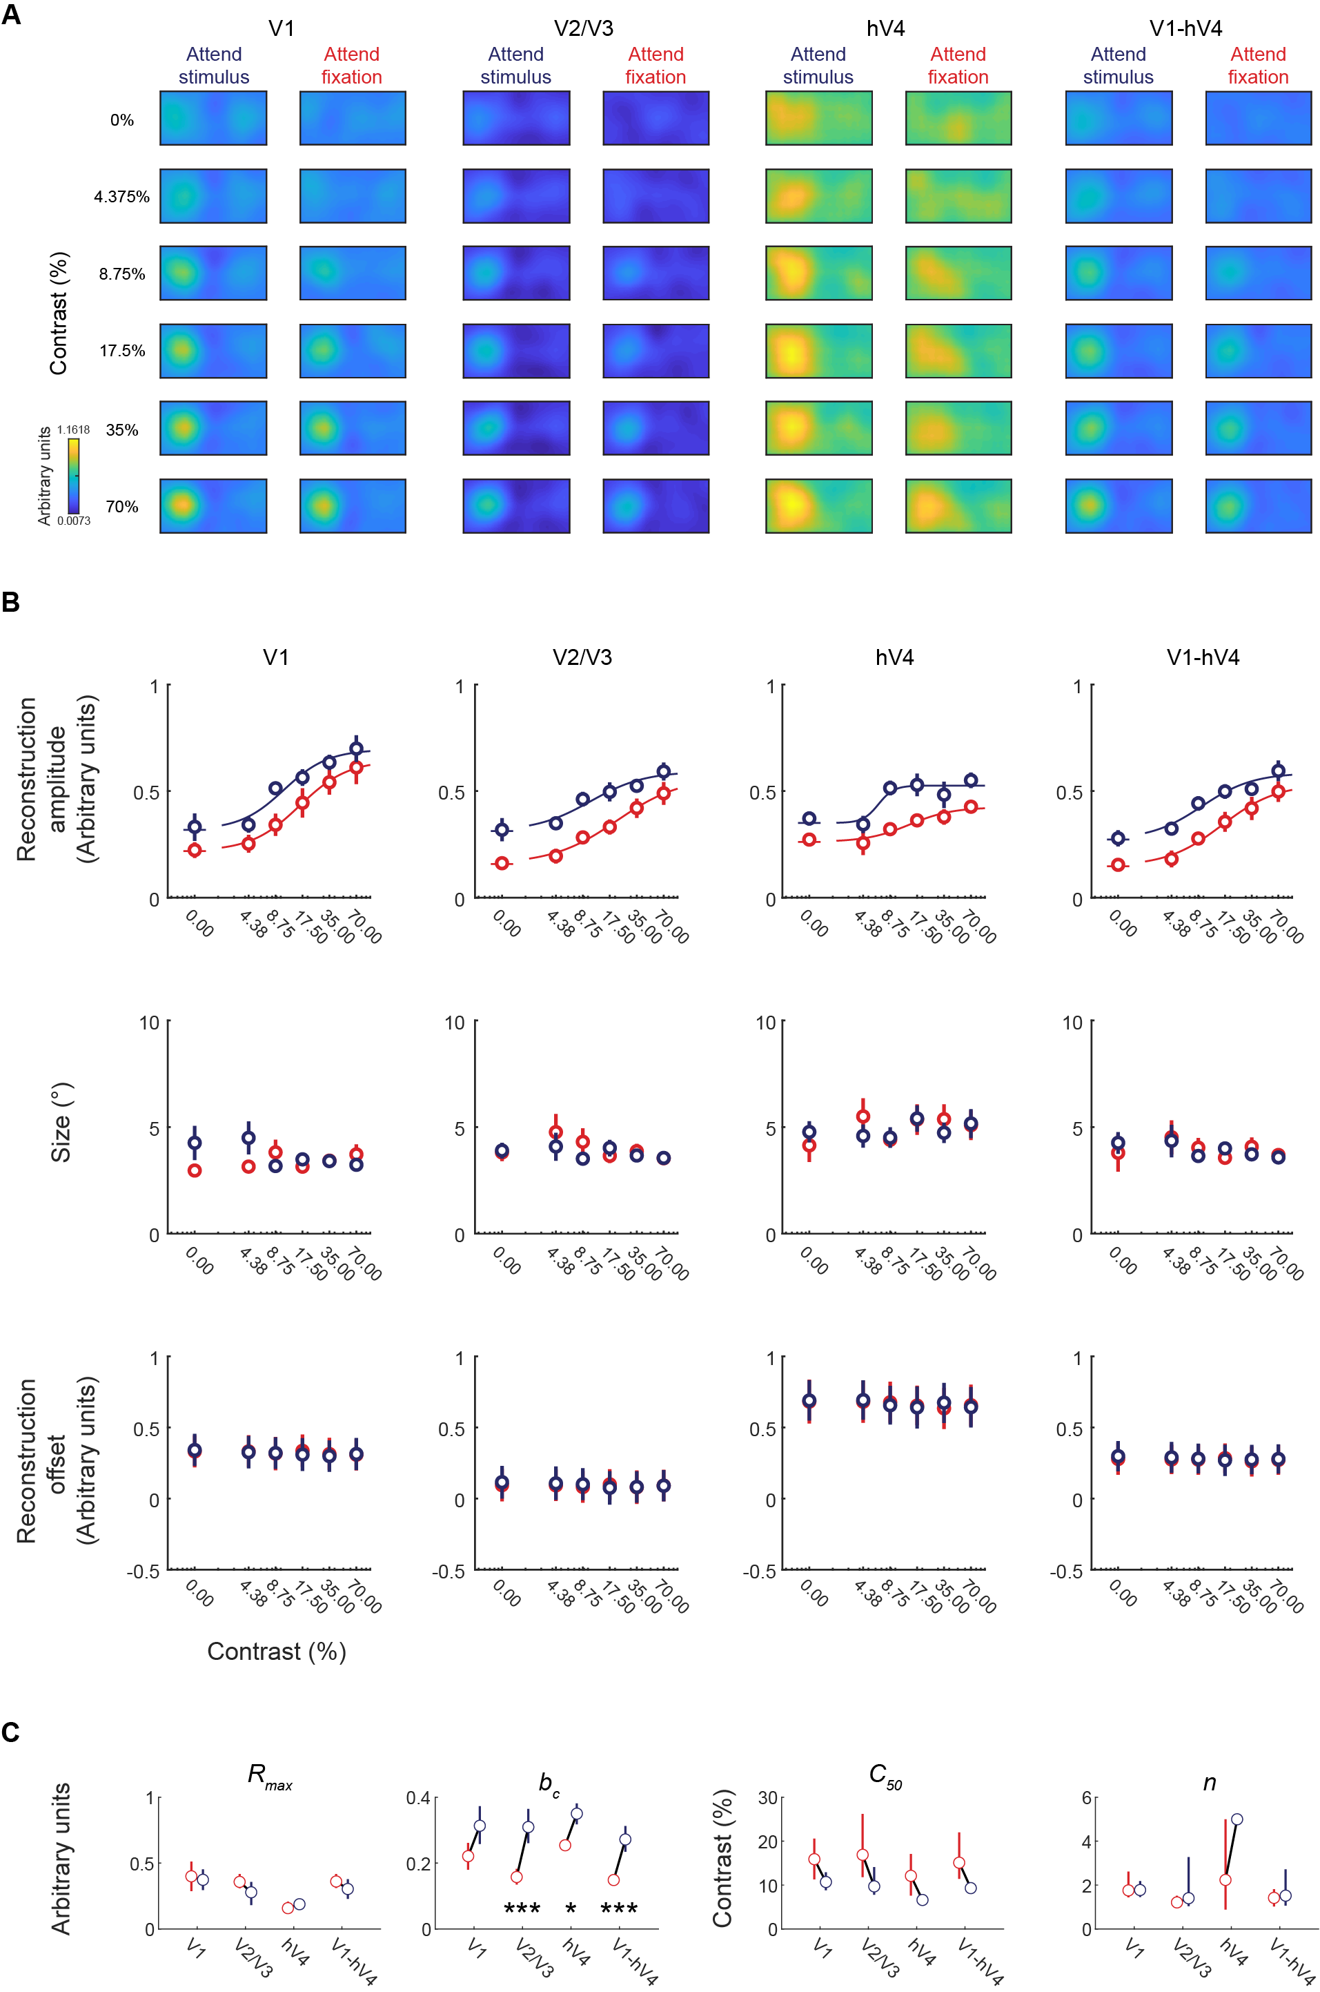Itthpuripat, Sprague, & Serences – EXTENDED DATA

Extended Data Figure 1 (caption on next page)
Extended Data Figure 1 Multivariate fMRI results across visual areas V1, V2/3, hV4, and V1-hV4 computed using high-contrast mapping stimuli. Data presented as in Figure 4, but computed using high-contrast mapping stimuli. (A) The spatial reconstructions of visual stimuli across different contrast and attention conditions. (B) The plots of the amplitude, size, and reconstruction offset parameters of the spatial reconstructions shown in (A) as a function of stimulus contrast across different attention conditions. (C) Corresponding Naka-Rushton fit parameters of the CRFs based on the amplitude (A) of surfaces fit to spatial reconstructions, shown in the top panels of (B). * and *** indicated significant differences between attention conditions (red = attend-fixation and blue = attend-stimulus) with p’s < 0.05 and p’s < 0.001, respectively. Error bars represent 68% CIs from resampling procedures. Results are overall consistent with those presented in Figure 4, except no significant different was found for R_{max} in any ROI, no significant difference in b_{c} was found for V1, and a significant difference in b_{c} was found in hV4.

